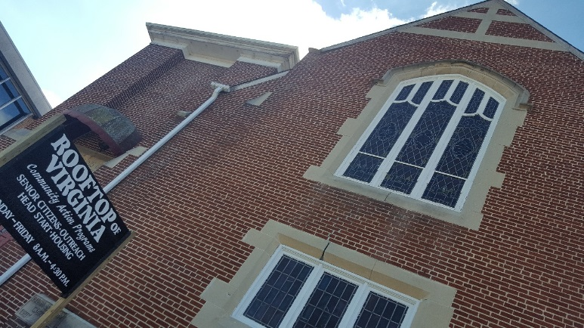Rooftop of Virginia CAP

**2019 Community Needs Assessment**

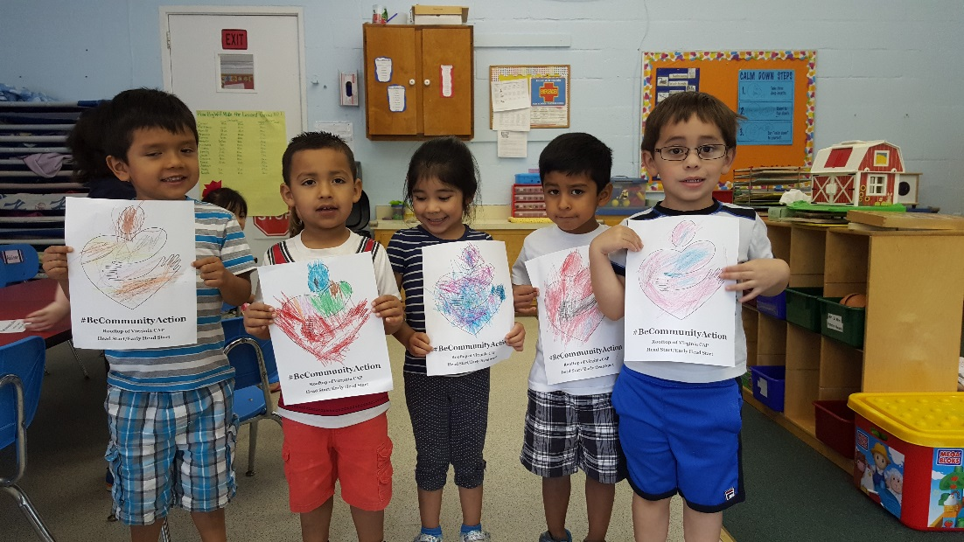

**Serving the City of Galax and the Counties of Carroll and Grayson since 1965.**

**206 North Main Street**

**PO Box 853**

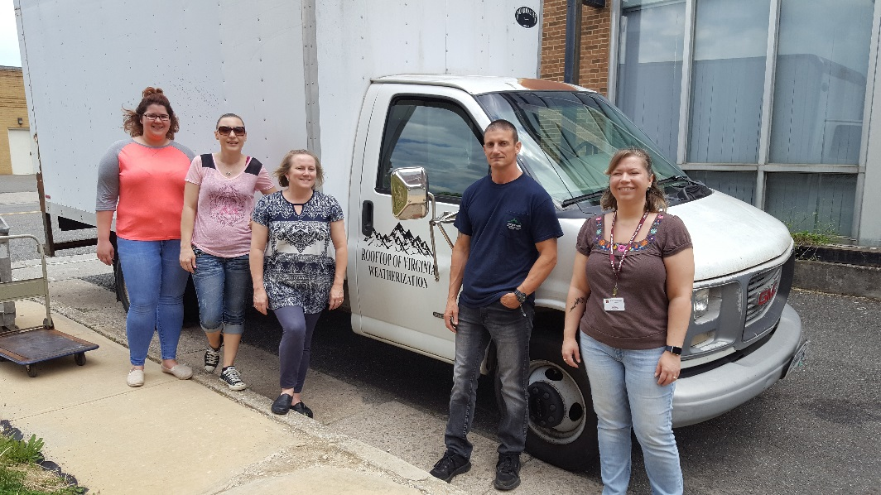**Galax, VA 24333**

**Phone: (276) 236-7131**

**Fax: (276) 236-7134**

**www.rtov.org**

**Table of Contents**

Executive Summary and Key Findings 2

Methodology 3

Overview of Service Area 4

Employment and Income 5

Education 7

Housing 9

Health and Wellness 11

Youth and Senior Citizens 14

Other Contributors to Poverty 18

Agency Needs 19

Area Assets 20

Appendices

-Quantitative 21

-Qualitative 50

**Executive Summary and Key Findings**

Rooftop of Virginia Community Action Program is housed in rural southwest Virginia and has served the area since 1965. The agency assists residents in the city of Galax and the counties of Carroll and Grayson. The primary responsibility of Rooftop of Virginia is to understand, document and respond to the community needs in the service area. In order to do so, the agency must engage in a comprehensive needs assessment triennial. This practice is not only mandated for Community Action Agencies but it is essential in order to seek to provide the most needed services and programs to area residents to aid them in reaching goals of economic and social independence. This Community Needs Assessment will not only be an established data source for Rooftop of Virginia; it will also be shared with other non-profits and local governments for their use in serving disadvantaged community members.

This assessment used a variety of data sources including surveys, interviews and public data. That information was analyzed by the staff and board to determine the top three needs of the area and are as follows:

1. **Employment**

While analyzing the data provided through compilation of resources, it was noted that two top employment needs were consistently mentioned. The first one is that area citizens and stakeholders would like to see the local governments (Grayson, Carroll and Galax) try to offer attractive incentives or packages to prospective businesses (community level need). An increase in businesses moving to the area will offer a larger job market and opportunities. The second employment need goes hand in hand with the first. The need for individuals to have a higher or more marketable skill sets that will enable them to obtain living-wage jobs (family level need). Please see page 5 for the definition of living wage jobs in the service area. The Twin Counties have seen job growth in areas that are traditionally low-paying sectors such as food service and retail. These jobs typically do not pay enough for families to sustain themselves. By obtaining more skills or credentials, the area’s workforce with be stronger and more inviting to prospective businesses.

1. **Substance Abuse**

The opioid drug epidemic is touching counties and cities nationwide. Galax, Grayson and Carroll are no different. It has been determined that the community lacks more preventative services and more post-recovery resources. The costs of opioid abuse, or substance abuse in general, is high in not only monetary ways such as medical emergencies and loss of employment due to drug use but also in social ways such as the need for more foster care and increasing rate in child abuse cases. This issue touches households and communities alike.

1. **Positive Activities for Youth**

While there are structured activities in some schools, organizations and faith-based groups, the area’s middle and high school children do not always have easy access to positive recreational or learning opportunities. After analysis, the agency concluded that the community lacks positive activities for youth. In collecting data for the Community Needs Assessment, this need was mentioned more than traditionally mentioned needs such as transportation or healthcare. Some hindrances to children participating in positive activities include a lack of structured programs, transportation and costs.

While the agency has identified the top three needs, other area necessities and key findings are listed throughout the remainder of the report.

**Methodology**

Rooftop of Virginia CAP collected data and information which they used to analyze and determine community needs, resources and opportunities for change. See the Appendices following the report for citations and data details.

**Quantitative Data**

Resources such as the US Census Bureau, Kids Count, Community Commons and more were used to gather statistics and secondary data. This was then used to support primary data and assisted the agency in analyzing how the local service area information compared to state and national data.

**Qualitative Data**

Statistics are very important to determine needs and areas of concern, but experienced opinions of stakeholders, citizens and more are also necessary to project how that the service region could be improved. The following are methods that the agency used to gather data in a qualitative manner:

*Staff Surveys and Focus Groups*

1. In December of 2017, the entire agency staff (85) met to participate in an Appreciative Inquiry. Staff members were tasked with determining the strengths, assets and opportunities of the agency’s service area.
2. Staff members (90) were brought together again in January of 2019. At this meeting, participants determined the top disparities in the area related to levels of need such as family, agency and community.
3. Employee satisfaction surveys were given to Head Start and Early Head Start employees during the 2017-2018 year. Staff members (28% participated) answered questions pertaining to suggestions to improving the program, training that is needed and how they could be better supported by management.
4. Employee satisfaction surveys were given to the main agency location staff members in the fall of 2018. Respondents (35% returned) answered questions regarding the quality of services provided, if improvements can be made and job satisfaction.
5. The management team comprised of nine staff members met in January of 2019, to analyze all data in attempts to determine the top three needs of the area.

*Customer Satisfaction Surveys*

In the fall of 2018, all programs offered customers an avenue to provide feedback on the agency’s services. A printed survey was provided and over 200 respondents answered questions regarding not only their satisfaction levels with staff and facility interaction but with what they considered contributors to poverty and their own household needs.

*Board Surveys*

In the fall of 2018, the agency’s Board of Directors were given surveys to determine the contributors to poverty as well as the levels of needs and assets of the community. Fifty percent of the board participated.

*Key Informant Interviews*

The three local directors for the Department of Social Services (Galax, Grayson, Carroll) were interviewed regarding their thoughts on the top three needs, ideas for improvements and assets of the area.

*Community Surveys*

A digital survey was provided to area citizens to determine top needs in the Twin Counties. The survey was provided as a link on the agency website as well as on the Facebook page. Ninety-one respondents provided their opinion on the contributors to poverty in the local area. They also rated levels of need in domains such as housing, employment and more

**Overview of Service Area**

The Twin County area (city of Galax and the counties of Carroll and Grayson) is nestled in the Blue Ridge Mountains in rural, Southwest Virginia. The area borders North Carolina and has access to major thoroughfares such as Interstates 77 and 81. Agriculture is an intrinsic part of the economy with the majority of providers operating in Carroll or Grayson Counties. Tourism plays a large part in the economic standing of the area due to access to the New River Trail, the Crooked Road, the Blue Ridge Parkway, Grayson Highlands State Park, historic main streets, annual festivals (for example, the Fiddler’s Convention and Smoke on the Mountain) and much more. Once an industry town with a focus on furniture manufacturing, the Twin Counties suffered when those factories closed because of jobs being relocated overseas. A boost in tourism through the revitalization of downtown Galax and more marketing of recreational opportunities has aided the area weather economic downturns.

While the service area has seen an economic rebound within the last few years, there are still a large number of households living in poverty. It is estimated that 19% of Twin County households are below the 100% Federal Poverty Guideline. The poverty rates of vulnerable populations such as children and seniors are well above state and national average. This alludes to the need for programs and services geared toward those ages in order to alleviate the causes and conditions of poverty.

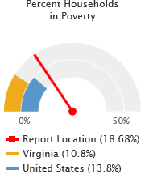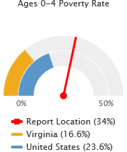 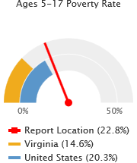 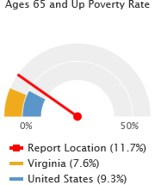

According to the 2016 US Census data, 51,771 people reside in the area. This is actually a decrease of about 4% in the last 16 years. Grayson County’s population has decreased more than Carroll or Galax and that seems to be due to younger residents relocating. The majority of the population are age 55 and over presenting a higher need for services for the elderly and aging. According to the American Community Survey (ACS) 2012-2016 5 year population estimates, the white population comprised 96.21% of the report area, black population represented 2.06%, and other races combined were 1.73%. Persons identifying themselves as mixed race made up 1.48% of the population. While the Hispanic and Latino communities are not predominant, the population has been increasing over the last decade and Rooftop of Virginia has seen more individuals and families seeking services. The agency responded to the need for bi-lingual staff and now has access to those that can interpret when the need arises.

**Employment and Income**

With average median income at only $37, 241, families struggle to maintain household responsibilities. Per the Economic Policy Institute, a family of four (2 adults and 2 children) in Rooftop of Virginia’s service area need an annual income of $69,331 (average) in order to “attain a modest yet adequate standard of living.” A vast majority of the population could only dream of reaching that income level. It has been determined through surveys and interviews that there are multiple job opportunities in the area, but they do not pay a living-wage. In other words, they do not offer a wage or benefits that can fully sustain a household.

Since the end of the recession, unemployment rates have dropped in the service area but stakeholders continue to identify availability and quality of jobs as a need. Underemployment contributes to poverty in that it affects all aspects of a household’s life; mental and physical health, substance abuse, transportation, quality housing and more. Since the area has lost what was once the backbone of the community, manufacturing jobs, residents are still trying to fit into the newer areas of growth such as accommodation fields and retail.

As mentioned in the agency’s determination of the top three needs of the area, making the Twin Counties attractive to potential businesses is a theme that occurred consistently throughout the survey and research process of the needs assessment. The second part of the need, potential employees with higher or more marketable skill sets, will assist the governments in marketing of the area to possible new enterprise. Individuals in the area do not have the skills that are needed for living-wage jobs.

Another issue that arises with individuals obtaining employment at lower wage jobs is that if they are receiving benefits such as SNAP (Supplemental Nutrition Assistance Program) or rental assistance, their assistance will be lowered due to the wage that they begin earning. There is no time frame that offers a buffer to allow those employed to ‘get on their feet’ before benefits are reduced. This issue can hinder the motivation for individuals to actually seek employment.

In community surveys, staff focus groups and stakeholder surveys, it was found that a lot of area residents lack the soft skills needed to obtain and maintain a job position. Skills such as how to complete a resume, what to wear to work and the need for maintaining job attendance are just a few soft skills that are necessary.

Resources have been identified by stakeholders and those that participated in the development of the Community Needs Assessments. These resources are geared toward employment and income related issues and is not comprehensive. This list names resources most repeatedly noted in interviews and surveys as well as those that are considered partners of Rooftop of Virginia CAP.

1. Virginia Employment Commission – The local office located in Galax can help with job search, unemployment claims and referrals to partners.
2. People Inc. – With the operation of the Workforce Investment and Opportunity Act (WIOA) programs focusing on youth and adults, staff members can assist eligible citizens with job search, training and supportive services.
3. Department of Social Services – May assist clients with supportive services.
4. Crossroads Institute – This facility is a great asset to the Twin Counties. Housing offices and classes for Wytheville Community College as well as small businesses, it serves as a central access point for those wishing to gain access to more skills or opportunities for employment.
5. Rooftop of Virginia CAP makes referrals to partner and other agencies to seek in assisting customers as needed.
6. Local governments work to grow and market assets to the community.
7. Rooftop of Virginia CAP provides the Outreach department which assists with emergency services such as rent and utilities.
8. The Volunteer Income Tax Assistance (VITA) program has been operated by Rooftop of Virginia CAP for 13 years. Volunteer tax preparers provide tax preparation services free of charge for area residents earning under $55,000. This aids in keeping more money in the pockets of citizens.

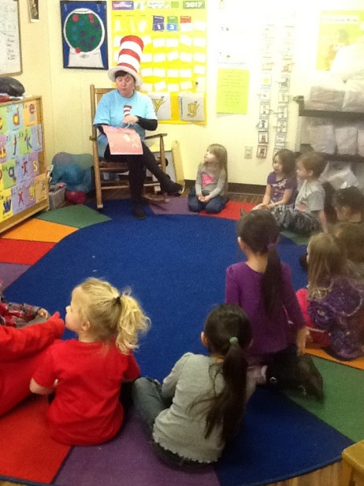

The Cat in the Hat Reads to a

group of children for Project READ.

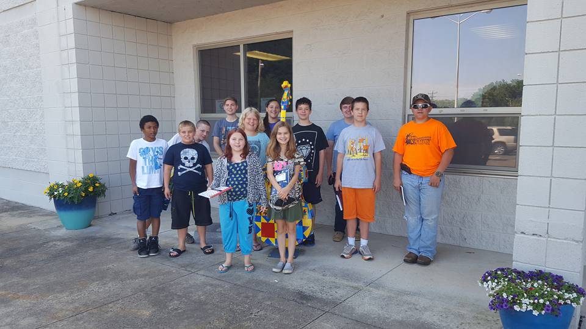

Camp SPARK visits the Crossroads Institute to learn about

career and training opportunities.

**Education**

In the graph below provided by The National Center for Higher Education Management Systems (2019), the difference in earning potential of those with high school diplomas and those with Bachelor’s degrees is fairly substantial. The state of Virginia shows a larger difference than the nation. In 2010, the difference in earnings was $28,454. This is the most recently supplied data but according to the trend on the chart, the difference would most likely be larger today. While this seems stark, it doesn’t take into account the jobs that are available with only certifications or certain credentials required. Those types of jobs would require less time than an advanced degree and would likely provide wages that were household sustaining. In 2017-2018, Rooftop of Virginia CAP served 2,274 individuals. Of that number, 65.5% were age 18 and older. A total of 29% of the working age individuals served have less than a high school diploma or GED. Disparity in skills and income of area residents can seriously hinder goals of self-sufficient communities.

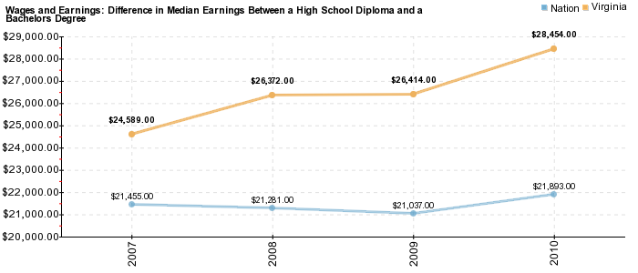

In analyzing all data collected pertaining to skill levels, Rooftop of Virginia CAP concluded that education and educational attainment is a path that leads to greater earnings and increased financial stability. Not all people are interested in obtaining a college degree. Some prefer to seek certificates or licenses for trades. Entering a vocational field can help with individuals beginning their career sooner, decrease in training costs and high need for trade jobs such as electrical and plumbing. There are valuable resources in the Twin Counties that will assist with increasing skills such as Wytheville Community College. It is a matter of residents recognizing their possibilities and committing to making themselves more marketable which in turn will make the community more marketable per the number one need identified in this needs assessment.

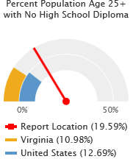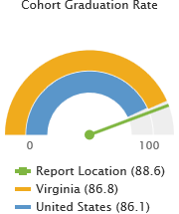While the Twin Counties have seen increasing high school graduation rates, there are still residents that do not have a diploma or GED.

Resources like GED classes and Adult Education are essential for growth in the under-educated. Obtaining a GED can mean the difference in a starting wage with a potential employer.

Community resources that assist with educational needs include but are not limited to the following:

1. GED classes are available at Mt. Rogers Regional Adult Education Program, Crossroads Institute Online class and at St. Paul Elementary school.
2. People Inc. provides the Workforce Investment and Opportunity Act (WIOA) which assists in providing employment and training opportunities to eligible youth and adults. They assist with supportive services as well.
3. The Crossroads Institute houses Wytheville Community College. Students may take classes toward a degree or certificate. Many classes are offered at the institute enabling students to remain closer to home instead of traveling to Wytheville.
4. Rooftop of Virginia CAP staff members make referrals to outside partners and services to seek to assist in their customers reaching educational goals.

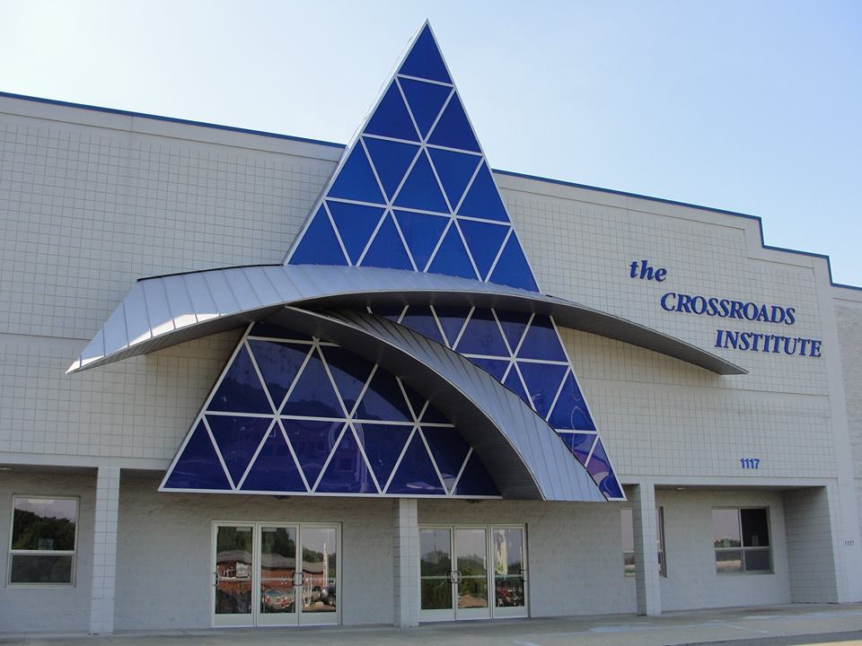

The Crossroads Institute in Galax.

**Housing**

The disparity of housing was a front runner for one of the top needs of Carroll, Grayson and Galax. It was actually the fourth most mentioned need by participants in the needs assessment process. Needs related to housing consist of the cost of utilities, credit issues hindering purchases, sub-standard housing and affordability. By far, the most mentioned issue is affordability.

Rental units in the area have shown increasing rates of rent (determined by a survey of the units leased in the rental assistance program housed at Rooftop of Virginia CAP) and the state’s fair market rents ([www.vhda.com](http://www.vhda.com)). Homeownership has become less attainable in recent years as housing costs have increased faster than incomes (National Low Income Housing Coalition - NLIHC). The majority (53%) of the individuals that are served by Rooftop of Virginia CAP are renters and 35% are homeowners. This is lower than the report area’s average of 57% in homeowners. HUD defines cost-burdened families as those “who pay more than 30 percent of their income for housing” and “may have difficulty affording necessities such as food, clothing, transportation, and medical care.” Severe rent burden is defined as paying more than 50 percent of one's income on rent. This is happening in the service area.

This indicator below reports the percentage of the households where housing costs exceed 30% of total household income. This indicator provides information on the cost of monthly housing expenses for owners and renters. The information offers a measure of housing affordability and excessive shelter costs. The data also serves to aid in the development of housing programs to meet the needs of people at different economic levels.

| **Report Area** | **Total Households** | **Cost Burdened Households (Housing Costs Exceed 30% of Income)** | **Percentage of Cost Burdened Households (Over 30% of Income)** |
| --- | --- | --- | --- |
| Report Location | 22,007 | 5,185 | 23.56% |
| Carroll County, VA | 12,517 | 2,913 | 23.27% |
| Grayson County, VA | 6,653 | 1,484 | 22.31% |
| Galax city, VA | 2,837 | 788 | 27.78% |
| Virginia | 3,105,636 | 942,435 | 30.35% |
| United States | 118,825,921 | 38,077,410 | 32.04% |

*Note: This indicator is compared to the state average.   
Data Source: US Census Bureau,* [*American Community Survey*](http://www.census.gov/acs/www/)*. 2013-17.*

In the Twin County area, available rental units have decreased in number. Confirmed data is not available that supports the reason for this. Data available for homeownership shows that credit issues of individuals and lack of knowledge on how to purchase a home hinders those seeking to buy. Research shows that those owning their own home report better financial stability, increased mental and physical health and better access to quality neighborhoods and resources (NLIHC).

Another issue related to housing is quality. Many survey respondents noted the presence of sub-standard housing in the area. This can lead to having less desirable neighborhoods which in turn decreases value of the community as a whole. Renter occupied units tend to be older than owner occupied units. This can cause lower-income renters to often be left with units that have weatherization, electrical or plumbing needs. Lower-income renters have fewer options in their price range and often settle for units that are low-quality or even unsafe.

Homelessness does not seem to be a dire need in the area. The agency reports that only about 1% of individuals served are homeless.

Resources in the area that are available to try to alleviate housing burdens include but are not limited to:

1. Rooftop of Virginia CAP
2. Virginia Housing Choice Voucher Program – provides safe and affordable rental assistance to over 300 area families.
3. Weatherization – gives eligible individuals access to quality home improvements related to the reduction of energy costs.
4. Emergency Home Repair – assists by removing imminent health and safety hazards and/or barriers to the habitability of eligible homes.
5. Indoor Plumbing Rehabilitation – provides assistance to low to moderate income owner-occupants of substandard housing where indoor plumbing does not exist or where existing water delivery or waste disposal system has failed.
6. Rural Development Loan Application Packaging – 502 loans seek to provide homeownership opportunities to very low or low income rural families; 504 loans and grants help to repair, improve, or update their home.
7. HOPE Inc. – helps with homelessness and housing assistance.
8. Subsidized Housing – income-based apartments
   1. Hillsville: Westview Terrace, Laurel Ridge
   2. Galax: Northway Apartments, Glendale Apartments
   3. Independence: Penn Court Apartments

[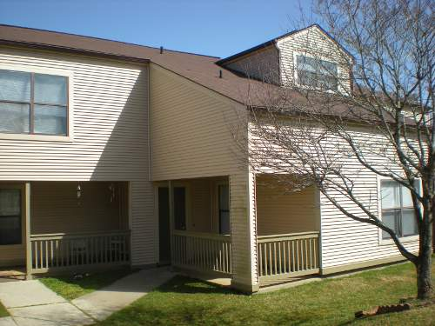](https://www.google.com/url?sa=i&rct=j&q=&esrc=s&source=images&cd=&cad=rja&uact=8&ved=2ahUKEwjpsve3w9ngAhXNmuAKHUPTAfQQjRx6BAgBEAU&url=https://www.apartmentsforrentnet.com/property/556/Laurel-Ridge-Apartments&psig=AOvVaw0PmZxZVv3QkUn88s4uFvfr&ust=1551274856229912)  
Laurel Ridge Apartments in Hillsville.

**Health, Nutrition and Wellness**

**Substance Abuse**

Substance abuse is at the forefront of feedback received by staff, board and community members. That is why Rooftop of Virginia CAP deemed it the number two highest need in the service area. In the past few years, opioid abuse has come to be a top concern for communities because of its direct impact on health, employment, child development and overall financial well-being of not only the home but of the community at-large. Substance abuse can be the underlying cause of poverty due to its links to many family and community issues.

This year, the National Safety Council deemed that the odds of accidentally dying from an opioid overdose in the US are now greater than those of dying in an automobile accident. Communities across the country are reeling from the effects of substance abuse and the Twin Counties are no different. One director from the local Department of Social Services stated that about 90% of foster care cases in the county are due to substance abuse. In 2018, the City of Galax joined forces with other localities to file a lawsuit against more than 15 opioid manufacturers and distributors. The lawsuit alleges that each defendant contributes to the opioid crisis in Southwest Virginia. In 2017, EMS administered over 2,300 does of Narcan (works to prevent overdose) in Galax, Grayson and Carroll. That is for ages 15-65+. An increase in costs pertaining to hospital visits, law enforcement and emergency services personnel, foster care and child placement services can present a high financial burden to communities.

In analyzing data provided for the needs assessment, team members were able to draw the conclusion that the need for prevention of substance abuse and post-recovery resources are what the service area lacks. Rooftop of Virginia CAP partnerships and other community organizations are striving to alleviate some of the needs. Local organizations like 4-H, Twin County Prevention Coalition and schools are trying to market the message to area youth pertaining to the hazards of drug use. Rooftop of Virginia CAP works with Head Start and Early Head Start parents and the Camp SPARK (middle school children) participants to stress the need to prevent substance abuse. Post-recovery resources may be obtained through the Life Center of Galax, Mt. Rogers CSB and God’s Storehouse. Even though those resources have been identified, assessment team members acknowledged that even more is needed to provide a more in-depth helping hand.

**Nutrition**

Obesity is a challenge nationwide, statewide and locally. In the Twin Counties, an average of 31% of adults are obese per the County Health Rankings provided by the Robert Wood Johnson Foundation. Obesity may lead to other health conditions that hinder an individual from meeting lifestyle goals. Resources available to help with this issue include the following:

1. Rooftop of Virginia CAP offers children under age five nutritious meals and snacks in the Early Head Start and Head Start programs. Participants of Camp SPARK are also provided guidance on choosing proper nutrition and are provided meals and snacks designed to meet body needs.
2. Local departments of health provide nutrition guidance to those receiving WIC and other services.

**Poor General Health, Disabilities and Insurance**

Within the report area 17% of adults age 18 and older self-report having poor or fair health in response to the question "would you say that in general your health is excellent, very good, good, fair, or poor?". This indicator is relevant because it is a measure of general poor health status.

| **Report Area** | **Total Population Age 18+** | **Estimated Population with Poor or Fair Health** | **Crude Percentage** | **Age-Adjusted Percentage** |
| --- | --- | --- | --- | --- |
| Report Location | 42,506 | 6,261 | 17% | 15.1% |
| Carroll County, VA | 24,113 | 3,472 | 14.4% | 12.7% |
| Grayson County, VA | 12,677 | 2,789 | 22% | 19.8% |
| Galax city, VA | 5,716 | No data | Suppressed | Suppressed |
| Virginia | 6,082,265 | 839,353 | 13.8% | 13.5% |
| United States | 232,556,016 | 37,766,703 | 16.2% | 15.7% |

*Note: This indicator is compared to the state average.   
Data Source: Centers for Disease Control and Prevention,* [*Behavioral Risk Factor Surveillance System*](http://www.cdc.gov/brfss/)*. Accessed via the* [*Health Indicators Warehouse*](http://healthindicators.gov/)*. US Department of Health & Human Services,* [*Health Indicators Warehouse*](http://www.healthindicators.gov/)*. 2006-12.*

As you can ascertain from the previous chart, general health of the area is lower than state and national averages. In a survey completed by the Head Start and Early Head Start programs through Rooftop of Virginia CAP, 17% of 261 families noted that someone in their household had an on-going health issue that makes life hard either every week or every day. Having a household struggle with health issues can hinder employment, educational attainment and self-sustainment.

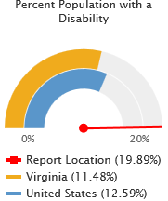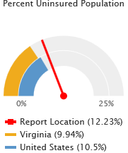Residents with disabilities in the service area are also higher than state and national averages. Out of all of the individuals served by Rooftop of Virginia CAP in 2017-2018, 80% were considered disabled. Senior Citizens encompass the largest group of disabled individuals. In the Head Start and Early Head Start programs, up to 10% of the 261 children enrolled receive disability related services. Those that are uninsured can sometimes ‘fall through the cracks’ when it comes to services for disabilities or just general health concerns. The recent expansion of Medicaid will assist more individuals and families

that struggled with this previously.

**Other Disparities**

1. Lack of affordable dental services for all ages was another concern that was voiced during data collection. The lack of dentists in the service area that accept Medicaid is a huge concern. Resources that are available usually take up to an hour drive or more. That makes accessibility low due to families already having issues with transportation.
2. The community does not have an abundance of resources for mental health providers. Again, residents are sometimes forced to drive elsewhere to obtain the services that are needed. This need could also be seen to coincide with the substance abuse problems the area is facing due to the fact that many drug abusers have and/or report a mental illness or condition.
3. Food scarcity is a challenge that some local residents face. Access to food or the resources to purchase food can be limited in families that have a high enough income to disqualify them from receiving SNAP (Supplemental Nutrition Assistance Program) assistance but not enough to cover all of the family’s food needs. Many schools in the area serve children that are eligible for free and reduced lunch, but that doesn’t help with members of the family not attending school.

Resources not previously mentioned in this section that available to alleviate health, nutrition and wellness issues include but are not limited to:

1. Food pantries such as PUSH Ministries and Willing Partners.
2. God’s Storehouse provides free dinner four nights per week.
3. The local departments of health seek to provide nutrition guidance to patients.
4. SMILES works with Rooftop of Virginia CAP’s Early Head Start and Head Start programs to provide preventative and minor corrective dental care to program participants.

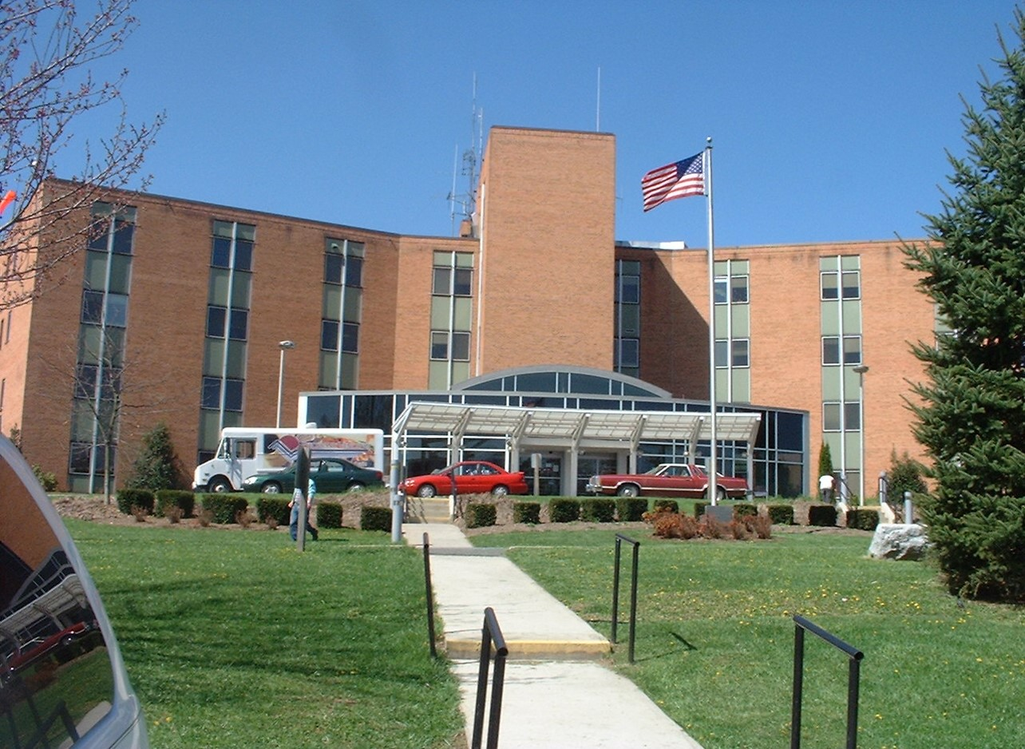

Twin County Regional Hospital has been serving the area since 1973.

**Youth and Senior Citizens**

**Middle and High School Children**

The third most mentioned need in the assessment data is the lack of positive activities for youth in the service area. This is the first time in many years that this need seemed to be more prevalent than in the past. One staff member noted that if children had opportunities for positive engagement, they would more likely develop and strive to reach personal and professional goals. In delving deeper into the topic, staff members decided that the age group that needs the most targeting is middle and high school children. The University of Washington determined that the age of early adolescence is a period of rapid physical and mental growth and it can be a time of pivotal change in the direction of a girl or boy. By providing positive activities, children are more likely to develop educational and cultural assets that will strengthen their future potential.

Activities doesn’t necessarily mean more movie theaters or game rooms. Assessment team members have determined that youth need access to structured, supportive activities or resources. While many schools offer athletic and educational opportunities for youth, oftentimes other factors hinder the ability of a child to participate. Limited transportation or lack of extra money in a household’s budget can keep a child from joining an activity. These issues lead to social isolation, especially in the rural service area.

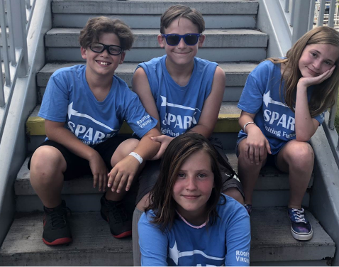Rooftop of Virginia CAP provides one avenue for children that might not usually be able to participate in an activity. Camp SPARK (Students Pursuing Academics, Resources and Knowledge) was formed in 2015. The one week day camp is operated twice during the summer. Rising 6th, 7th and 8th grade students from Grayson, Carroll and Galax are eligible to attend and participate in activities related to education, future careers and just general fun. The camp promotes positive behaviors and strives to provide positive support to the children. The camp is free of charge and gives registration preference to those in vulnerable households like single-parent homes, foster homes or lower income. The agency recognizes the need for on-going mentoring services and would like to extend the program at some point.

**Child Care and Early Childhood Education**

The lack of affordable child care facilities is an issue that has haunted the area for years. Parents and caregivers often must decide between working and/or training opportunities versus the ability to secure quality, affordable child care. While the Department of Social Services assists with subsidies for child care, not all parents are eligible and not all sitters will accept subsidies. Early Head Start offered by Rooftop of Virginia CAP serves all localities in the area. The program cares for ages 0-3. The following chart shows the current child care options (does not account for private sitters that are wither relatives or friends):

|  |  |  |  |
| --- | --- | --- | --- |
| **Type of Setting** | **Grayson** | **Carroll** | **Galax** |
| Early Head Start/Head Start | 2 | 2 | 2 |
| Licensed Day Care | 0 | 4 | 0 |
| Church | 1 | 2 | 1 |
| In-Home | 1 | 5 | 3 |

Rooftop of Virginia CAP works well with area schools in the Virginia Preschool Initiative. The goal is to provide exceptional preschool programs for at-risk 4 year olds unserved by the Head Start Program. The following provides information on the number of children ages 0-5 being served:

Early Head Start – 116, Head Start – 145 (43 children age 3 and 102 age 4-5), Grayson – 18 (one site in Fries), Carroll – 136 (7 sites throughout the county), Galax – 54 (one site in the city)

There are 2,696 children under the age of 5 in the report area. A total of 469 are being served through Early Head Start, Head Start and the preschools.

Virginia has implemented multiple initiatives and programs with the goal of improving the quality of child care and early childhood education. The Virginia Quality program helps to support child care providers with assistance and systems to improve the quality of care. Centers are rated with ‘stars’ to indicate the level of quality and policy adherence. Smart Beginnings, headed by the Virginia Early Childhood Foundation, works to build capacity to provide quality early childhood development at the local level. Even with these initiatives, access to care that is both high quality and affordable remains a barrier to many families.

Centers in the service area with STAR ratings:

|  |  |  |  |  |
| --- | --- | --- | --- | --- |
| **CENTER** | **ADDRESS** | **PHONE** | **STAR RATING** | **AGE RANGE** |
| CANA HEAD START | 231 FLOWER GAP RD.  CANA, VA 24317 | (276) 236 7131 | 3 | 3 YRS – 5YRS |
| HILLSVILLE HEAD START/ EARLY HEAD START | 205 OAK ST.  HILLSVILLE, VA 24343 | (276) 728 4284 | 3 | INFANT, TODDLERS, 3 YRS – 5YRS. |
| LIDDLE ADVENTURES LEARNING ACADEMY | 564 INDUSTRIAL PARK DR  HILLSVILLE VA 24343 | (276) 728 5793 | 2 | INFANT, TODDLER, 3YRS – 5 YRS, SCHOOL AGE |
| LIDDLE TYKES CHILD DEVELOPMENT CENTER | 59 MELROSE LN  GALAX, VA 24333 | (276) 236 3421 | 2 | INFANT, TODDLER, 3YRS – 5 YRS, SCHOOL AGE |
| LITTLE TREASURES LEARNING CENTER | 2875 WARDS GAP RD  CANA, VA 2431 | (276) 755 0145 | 2 | INFANT, TODDLER, 3YRS – 5 YRS, SCHOOL AGE |
| MS. DEBRA HOOVEN | 99 GREEN PINE LN  FANCY GAP, VA 24328 | (276) 728 2527 | 2 | INFANT, TODDLER, 3YRS – 5 YRS, SCHOOL AGE |
| GALAX EARLY HEAD START | 8342 CARROLLTON PIKE  GALAX, VA 24333 | (276) 237-6786 | 4 | INFANT AND TODDLER |
| GALAX HEAD START | 125 ROSENWALD FELTS DR  GALAX VA 24333 | (276) 238 8633 | 3 | 3 YRS-5 YRS. |
| INDEPENDENCE EARLY HEAD START | 911 E MAIN STREET  INDEPENDENCE VA 24348 | (276) 233-9635 | 4 | INFANT AND TODDLER |
| INDEPENDENCE HEAD START | 911 E MAIN ST  INDEPENDENCE VA 24348 | (276) 233-9635 | 3 | 3 YRS- 5YRS |

**Foster Care**

The number of children placed in foster care has increased in recent years. Factors such as substance abuse, physical abuse and more cause children to be removed from their homes. A lack of families registered to take foster placements is an issue in the area and means that sometimes children are forced to be placed in another area which causes a higher expense to localities. The local newspaper, The Gazette, reported in February 2019, that with the influx of foster children in Galax, the city was requesting a budget amendment to cover in the increased costs. As of February 2019, Carroll County reports 87 children in foster care, Grayson County is serving 30 and Galax has 52. The following graphic illustrates the local children placed in foster care in 2018:

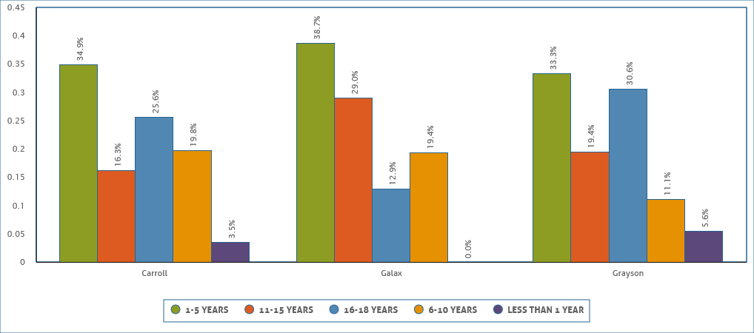

**Senior Citizens**

With an aging population due to baby boomers and an influx of seniors coming to the area because of the lower cost of living, the need for services for seniors is growing. Locally, the majority of the population is aged 55 and over. Aging residents in the area provide a greater challenge to communities to provide needed services. Necessities such as access to medical and dental facilities, opportunities for home care and senior housing are just a few of topics that were mentioned in a staff focus group. Another topic that was mentioned multiple times in a staff focus group was the need for senior day care facilities. Currently, the area does not have this service being offered. Families can be forced to choose between work and staying home to care for an aging household member. This can lead to a decrease of income and an increase in the need of supportive services.

Because of the rural area, studies have shown that seniors sometimes face social isolation. This is in part to lack of accessible public transportation, lack of social opportunities and shortage of funds to provide services. Rooftop of Virginia CAP has sought to alleviate some of the isolation by operating the Senior Citizens program in partnership with District III. Twice weekly, adults age 60 and over meet at the main agency location for a nutritious meal and socialization. Participants enjoy games, musical guests, occasional trips and much more.

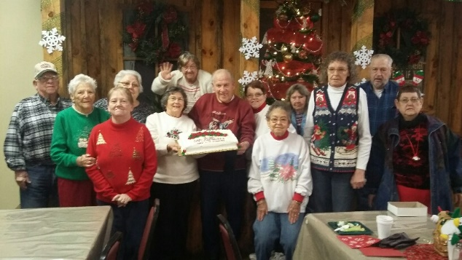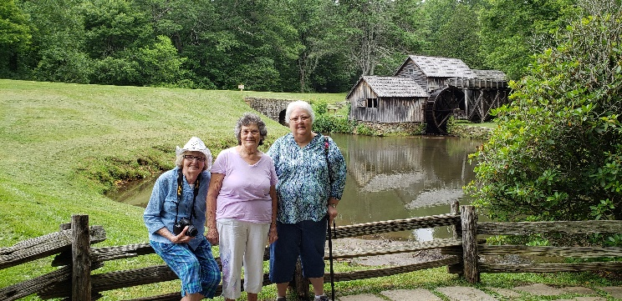

Resources available to meet needs not previously mentioned in this section include but are not limited to the following:

1. Rooftop of Virginia CAP provides the Co-Parenting Class which is a Supreme Court of Virginia approved class that provides parents and/or caregivers with the information needed to ensure children are being properly cared for in separate homes.
2. The need for early literacy is stressed by Rooftop of Virginia CAP through the efforts of Project READ. Studies have shown the importance of reading to children at least 20 minutes daily and how that practice can lead to future successes for children. The project provides books to newborns as the local hospital, local foster children, Joy Ranch Home for Children, through agency programs like Early Head Start, Head Start and Camp SPARK and also hands out books during community events.

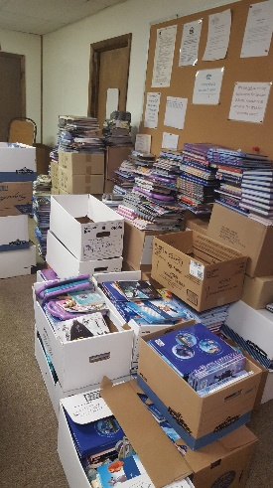

Just some of the books that Rooftop of Virginia CAP and partners were able to give to children in the community through Project READ.

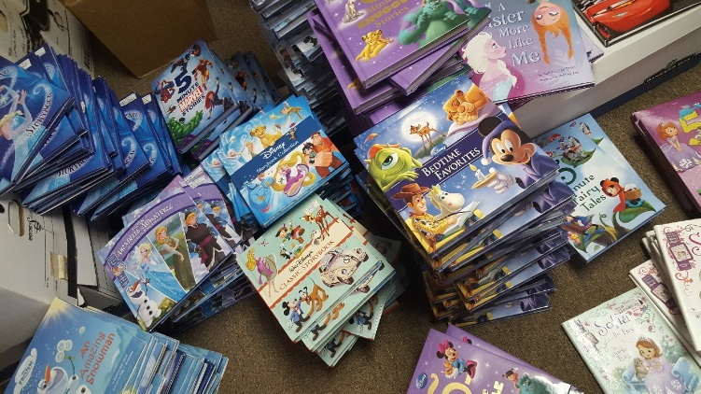

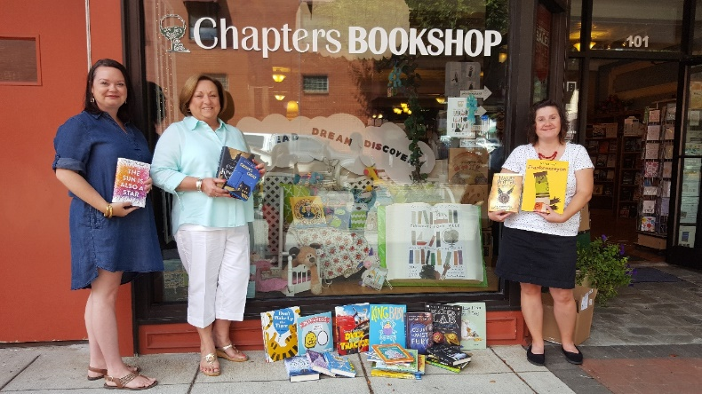 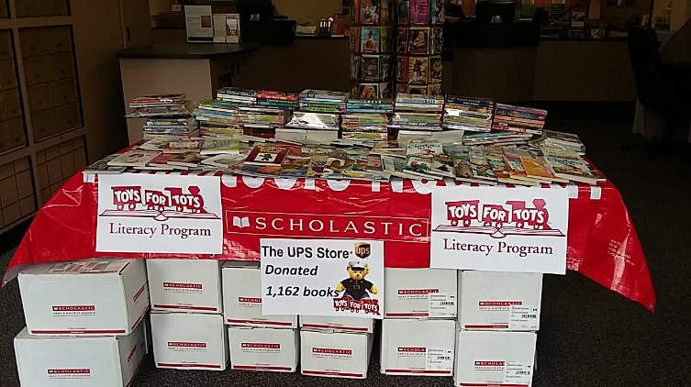

**Other Contributors to Poverty**

Through the needs assessment process, Rooftop of Virginia CAP discovered other underlying challenges that face the community. These issues were thought to not fit directly into previous domains but rather effect all aspects of community life.

1. The community lacks public transportation. The city of Galax has a limited day and time transit system that only operates in the city limits. Neither county has public transportation.
2. There is a growing number of grandparent or a relative other than a parent heading households with children. The number of children being removed from their parents’ homes and placed with other relatives in increasing annually. Grandparents, especially, are lacking the proper resources and assistance in raising children in a more modern time than when they might have originally raised children. The lack of knowledge of technology alone can hinder a grandparent from accessing services that they might be eligible for or even helping a child with their homework.
3. Included in a satisfaction survey, customers were asked to list the top three needs that their household faces. The number most indicated challenge is the cost of utilities. Electric costs can sometimes cause families to be cost burdened. There is only one resource for electricity in the area which can cause prices to be unchallenged.

[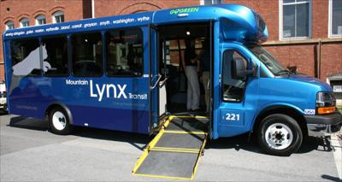](https://www.google.com/url?sa=i&rct=j&q=&esrc=s&source=images&cd=&ved=2ahUKEwiUn_-S3dngAhVRhuAKHd_tD50QjRx6BAgBEAU&url=https://www.swvatoday.com/news/smyth_county/article_a80d2410-4d53-11e7-b3f5-c3334ea9130b.html&psig=AOvVaw0mPSejiHCRTJdSRch_fRzW&ust=1551281698879459)

The Mountain Lynx Transit is the only public transportation in the area.

It only services the City of Galax.

**Agency Needs**

In discussing needs of the community, Rooftop of Virginia CAP completed an internal assessment of the programs, employee satisfaction and overall functioning of the agency. Since the agency’s vision is to be the foundation for building a self-sufficient community, it is important to regularly analyze agency effectiveness in helping to alleviate needs in the community. The following were the top three areas that the agency would like to improve upon:

1. Marketing

Although the agency has been serving the Twin Counties since 1965, many area citizens do not fully recognize what Rooftop of Virginia CAP has to offer. Some see the agency as being where you go for Head Start services. Others think that only low income people are served. In actuality, many programs offered by the agency may be accessed by many area residents. Attempts to better market the availability of not only one certain service but to offer many program options to provide a whole family approach to assisting with needs is what the agency would like to achieve.

1. Volunteers

While the agency is proud to boast competent and committed staff, there is always a need for more hands to help. Volunteers can play a vital role in not only the operation of the agency but in making change for individuals and families. Funds are limited and staff time can sometimes only cover the necessities. With the help of volunteers, the agency feels that their mission can better be met. Rooftop of Virginia CAP is currently developing a volunteer manual and plan to reach their goal of obtaining and maintaining a volunteer base.

1. Main Facility Improvements

The agency has been operating in a building that is over 100 years old. While staff and customers alike can admire the charm and character of the site, the age of the building produces the need for continuous improvements. Cosmetic improvements have been made where possible and staff members are proud and happy with the upgrades. The roof is in need of replacing and the electrical service is outdated. The agency is working to secure funding to make the necessary repairs so that staff can focus on helping others and not emptying buckets of rain water from their offices.

*Mission:* “In partnership with our community, Rooftop of Virginia CAP empowers individuals and families by offering and facilitating resources to achieve economic and social independence.”

*Slogan:* “Igniting Futures, Improving Lives, Building Communities”

*Vision:* “Rooftop of Virginia Community Action Program will be the foundation for building self-sufficient communities.”

**Area Assets**

A Community Assessment would not be complete without looking at the strengths that the area has to offer. All participants of the needs assessment process were asked to identify assets and resources that make the community a good place to live. The following are responses that were provided:

1. An active law enforcement and emergency medical services.
2. Natural beauty of the area.
3. Recreational opportunities related to the local parks and New River trail as well as The Carroll Wellness Center and Galax Parks and Recreation.
4. Many active churches in the area that make it their goal to help those in the community.
5. Many free community events.
6. Schools are of higher quality.
7. A general ‘sense of community’ and willingness to help others.
8. Low crime rate.

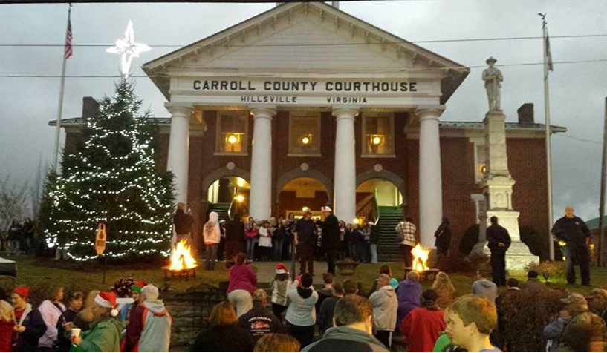



A holiday event in Hillsville.

The beauty of the New River in Grayson County

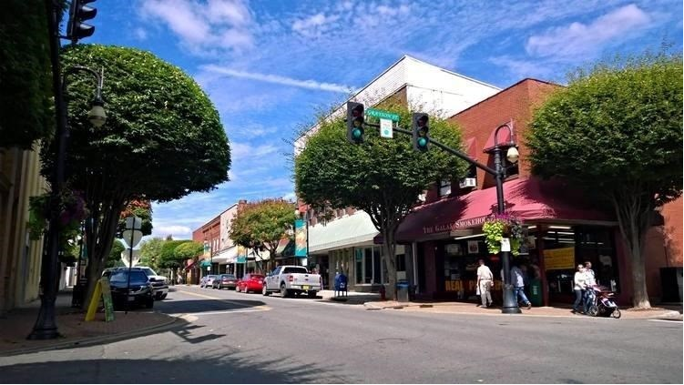

Main Street in Galax.

**Appendices**

**Quantitative Data**

*Rooftop of Virginia CAP data collected 2019-2020. Provided by Empowor.*

|  |  |  |  |  |  |  |  |
| --- | --- | --- | --- | --- | --- | --- | --- |
| **Age** |  | | | |  |  |  |
| 0-5 | 412 | | 14.28% | | | |  |
| 6-13 | 428 | | 14.83% | | | |  |
| 14-17 | 159 | | 5.51% | | | |  |
| 18-24 | 241 | | 8.35% | | | |  |
| 25-44 | 746 | | 25.85% | | | |  |
| 45-54 | 307 | | 10.64% | | | |  |
| 55-59 | 157 | | 5.44% | | | |  |
| 60-64 | 127 | | 4.40% | | | |  |
| 65-74 | 211 | | 7.31% | | | |  |
| 75 and older | 98 | | 3.40% | | | |  |
| Unknown | 0 | | 0.00% | | | |  |
| **Race** |  | | | |  |  |  |
| American Indian / Alaska Native | 0 | | 0.00% | | | |  |
| Asian | 0 | | 0.00% | | | |  |
| Black/ African American | 236 | | 8.18% | | | |  |
| Client refused to answer | 0 | | 0.00% | | | |  |
| Native Hawaiian or Other Pacific Islander | 0 | | 0.00% | | | |  |
|  |  |  |  |  |  |  |
| Other Race | 49 | | 1.70% | | | |  |
| White | 2435 | | 84.37% | | | |  |
| Multi Race | 127 | | 4.40% | | | |  |
| **Ethnicity** |  | | | |  |  |  |
| Chose not to respond/Refused/Did not self identify | 0 | | 0.00% | | | |  |
|  |  |  |  |  |  |  |
| Hispanic / Latino | 346 | | 11.99% | | | |  |
| Non-Hispanic / Not Latino | 2532 | | 87.73% | | | |  |
| **Disability** |  | | | |  |  |  |
| Disabled | 440 | | 15.25% | | | |  |
| Not Disabled | 2410 | | 83.51% | | | |  |
| Pending - Disability | 35 | | 1.21% | | | |  |
| **Education Level** |  | | | |  |  |  |
| 0 to 8th Grade | 1041 | | 36.07% | | | |  |
| 12+ Some Post Secondary | 248 | | 8.59% | | | |  |
| 9-12 Non-Graduate | 536 | | 18.57% | | | |  |
| Associate's Degree | 105 | | 3.64% | | | |  |
| Bachelors Degree | 58 | | 2.01% | | | |  |
| Completed High School | 856 | | 29.66% | | | |  |
| GED | 2 | | 0.07% | | | |  |
| Industry Recognized Vocational Certification (i.e. Master Plumber) | 7 | | 0.24% | | | |  |
|  |  |  |  |  |  |  |
| Masters Degree | 1 | | 0.03% | | | |  |
| Youth ages 14-24 not working or in school | 0 | | 0.00% | | | |  |
|  |  |  |  |  |  |  |
| **Employment Status** |  | | | |  |  |  |
| Employed-Full time | 578 | | 20.03% | | | |  |
| Employed-Part time (including multiple part time jobs) | 257 | | 8.91% | | | |  |
|  |  |  |  |  |  |  |
| Not in Labor Force | 336 | | 11.64% | | | |  |
| Retired | 234 | | 8.11% | | | |  |
| School/Job Training Program | 2 | | 0.07% | | | |  |
| Season/Temporary Employment | 10 | | 0.35% | | | |  |
| Unemployed (< 6 Months) | 126 | | 4.37% | | | |  |
| Unemployed (>6 Months) | 263 | | 9.11% | | | |  |
| **Gender** |  | | | |  |  |  |
| Doesn't identify as male, female or transgender | 0 | | 0.00% | | | |  |
|  |  |  |  |  |  |  |
| Female | 1639 | | 56.79% | | | |  |
| Male | 1246 | | 43.17% | | | |  |
| Transgender-Female to Male | 0 | | 0.00% | | | |  |
| Transgender-Male to Female | 1 | | 0.03% | | | |  |
| **Marital Status** |  | | | |  |  |  |
| Divorced | 246 | | 8.52% | | | |  |
| Married | 570 | | 19.75% | | | |  |
| Partners | 148 | | 5.13% | | | |  |
| Separated | 51 | | 1.77% | | | |  |
| Single | 726 | | 25.16% | | | |  |
| Widowed | 103 | | 3.57% | | | |  |
| **Veteran Status** |  | | | |  |  |  |
| Active Military | 0 | | 0.00% | | | |  |
| Never Served | 1781 | | 61.71% | | | |  |
| Unkown | 1 | | 0.03% | | | |  |
| Veteran | 69 | | 2.39% | | | |  |
| **Health Insurance** |  | | | |  |  |  |
| Insured-Employer Provided | 254 | | 8.80% | | | |  |
| Insured-Medicaid | 1704 | | 59.04% | | | |  |
| Insured-Medicare | 261 | | 9.04% | | | |  |
| Insured-Private Pay/Direct Purchase | 45 | | 1.56% | | | |  |
|  |  |  |  |  |  |  |
| Insured-SCHIP | 2 | | 0.07% | | | |  |
| Insured-State Health Insurance for Adults | 3 | | 0.10% | | | |  |
|  |  |  |  |  |  |  |
| Insured-Unknown Type | 115 | | 3.98% | | | |  |
| Insured-VA Medical Services | 21 | | 0.73% | | | |  |
| No Health Insurance | 360 | | 12.47% | | | |  |
| Multi HealthInsurance | 114 | | 3.95% | | | |  |
| **Languages** |  | | | |  |  |  |
| All Other Languages | 0 | | 0.00% | | | |  |
| Asian and Pacific Island Languages | 2 | | 0.07% | | | |  |
|  |  |  |  |  |  |  |
| English | 2633 | | 91.23% | | | |  |
| Middle Eastern and South Asian Languages (e.g. Arabic, Hebrew, Hindi, Urdu, Bengali) | 0 | | 0.00% | | | |  |
|  |  |  |  |  |  |  |
| Native Central American, South American, and Mexican Languages | 0 | | 0.00% | | | |  |
|  |  |  |  |  |  |  |
| Other Indo-European Languages | 0 | | 0.00% | | | |  |
| Spanish | 182 | | 6.31% | | | |  |
| Multi Language | 40 | | 1.39% | | | |  |
|  |  | |  | | | |  |
| **Most Recent Income-% to Poverty** |  | | | |  |  |  |
|  |  |  |  |  |  |  |
| 0-50% | 356 | | 25.93% | | | |  |
| 50.01-75% | 235 | | 17.12% | | | |  |
| 75.01-100% | 233 | | 16.97% | | | |  |
| 100.01-125% | 139 | | 10.12% | | | |  |
| 125.01-150% | 80 | | 5.83% | | | |  |
| 150.01-175% | 52 | | 3.79% | | | |  |
| 175.01-200% | 43 | | 3.13% | | | |  |
| Over 200% | 170 | | 12.38% | | | |  |
| **Family Type** |  | | | |  |  |  |
| Multi-generational Household | 69 | | 5.03% | | | |  |
| Non-related Adults with Children | 20 | | 1.46% | | | |  |
| Single Parent (Father figure w/Partner) | 1 | | 0.07% | | | |  |
|  |  |  |  |  |  |  |
| Single Parent (Father only) | 15 | | 1.09% | | | |  |
| Single Parent (Mother figure w/Partner) | 16 | | 1.17% | | | |  |
|  |  |  |  |  |  |  |
| Single Parent (Mother only) | 210 | | 15.29% | | | |  |
| Single Person-Only 1 person in the household | 762 | | 55.50% | | | |  |
|  |  |  |  |  |  |  |
| Two Adults-No Children in HH | 70 | | 5.10% | | | |  |
| Two or more unrelated adults | 7 | | 0.51% | | | |  |
| Two Parent Household/Family | 186 | | 13.55% | | | |  |
| Family Type Not Entered | 15 | | 1.09% | | | |  |
| **Housing Status** |  | | | |  |  |  |
| Homeless (With Roof) | 20 | | 1.46% | | | |  |
| Homeless (Without Roof) | 0 | | 0.00% | | | |  |
| Homeowner | 524 | | 38.16% | | | |  |
| Other | 61 | | 4.44% | | | |  |
| Other Permanent Housing (i.e. long term care, Joy Ranch) | 8 | | 0.58% | | | |  |
|  |  |  |  |  |  |  |
| Rent | 742 | | 54.04% | | | |  |
| Housing Status Not Entered | 18 | | 1.31% | | | |  |
| **Household Total: 1373** | **Participant Total: 2886** | | | |  |  |  |

*Rooftop of Virginia CAP data collected 2017-2018. Provided by Empowor.*

|  |  |  |  |  |  |  |  |
| --- | --- | --- | --- | --- | --- | --- | --- |
| **Age** |  | | | |  |  |  |
| 0-5 | 349 | | 15.34% | | | |  |
| 6-13 | 305 | | 13.41% | | | |  |
| 14-17 | 128 | | 5.63% | | | |  |
| 18-24 | 175 | | 7.69% | | | |  |
| 25-44 | 479 | | 21.05% | | | |  |
| 45-54 | 283 | | 12.44% | | | |  |
| 55-59 | 132 | | 5.80% | | | |  |
| 60-64 | 122 | | 5.36% | | | |  |
| 65-74 | 195 | | 8.57% | | | |  |
| 75 and older | 107 | | 4.70% | | | |  |
| Unknown | 0 | | 0.00% | | | |  |
| **Race** |  | | | |  |  |  |
| Hispanic | 41 | | 1.80% | | | |  |
| American Indian / Alaska Native | 1 | | 0.04% | | | |  |
| Asian | 0 | | 0.00% | | | |  |
| Black/ African American | 215 | | 9.45% | | | |  |
| Native Hawaiian or Other Pacific Islander | 0 | | 0.00% | | | |  |
|  |  |  |  |  |  |  |
| Other Race | 47 | | 2.07% | | | |  |
| Unknown/Not Reported | 4 | | 0.18% | | | |  |
| White | 1853 | | 81.45% | | | |  |
| Multi Race | 114 | | 5.01% | | | |  |
| **Ethnicity** |  | | | |  |  |  |
| Chose not to respond/Refused/Did not self identify | 0 | | 0.00% | | | |  |
|  |  |  |  |  |  |  |
| Hispanic / Latino | 199 | | 8.75% | | | |  |
| Non-Hispanic / Not Latino | 2042 | | 89.76% | | | |  |
| Unknown/Not Reported | 34 | | 1.49% | | | |  |
| **Disability** |  | | | |  |  |  |
| Disabled | 434 | | 19.08% | | | |  |
| Not Disabled | 1831 | | 80.48% | | | |  |
| Pending - Disability | 9 | | 0.40% | | | |  |
| **Education Level** |  | | | |  |  |  |
| 0 to 8th Grade | 101 | | 4.44% | | | |  |
| 12+ Some Post Secondary | 206 | | 9.05% | | | |  |
| 9-12 Non-Graduate | 361 | | 15.87% | | | |  |
| Associate's Degree | 82 | | 3.60% | | | |  |
| Bachelors Degree | 39 | | 1.71% | | | |  |
| Completed High School or GED | 607 | | 26.68% | | | |  |
| Industry Recognized Vocational Certification (i.e. Master Plumber) | 1 | | 0.04% | | | |  |
|  |  |  |  |  |  |  |
| Unknown/Not Reported | 70 | | 3.08% | | | |  |
| Youth ages 14-24 not working or in school | 0 | | 0.00% | | | |  |
|  |  |  |  |  |  |  |
| **Employment Status** |  | | | |  |  |  |
| Employed-Full time | 336 | | 14.77% | | | |  |
| Employed-Part time (including multiple part time jobs) | 231 | | 10.15% | | | |  |
|  |  |  |  |  |  |  |
| Not in Labor Force | 235 | | 10.33% | | | |  |
| Retired | 288 | | 12.66% | | | |  |
| School/Job Training Program | 0 | | 0.00% | | | |  |
| Season/Temporary Employment | 5 | | 0.22% | | | |  |
| Unemployed | 80 | | 3.52% | | | |  |
| Unemployed (< 6 Months) | 79 | | 3.47% | | | |  |
| Unemployed (>6 Months) | 205 | | 9.01% | | | |  |
| Unknown/Not Reported | 15 | | 0.66% | | | |  |
| **Gender** |  | | | |  |  |  |
| Doesn't identify as male, female or transgender | 0 | | 0.00% | | | |  |
|  |  |  |  |  |  |  |
| Female | 1320 | | 58.02% | | | |  |
| Male | 955 | | 41.98% | | | |  |
| Transgender-Female to Male | 0 | | 0.00% | | | |  |
| Transgender-Male to Female | 0 | | 0.00% | | | |  |
| **Marital Status** |  | | | |  |  |  |
| Divorced | 226 | | 9.93% | | | |  |
| Married | 415 | | 18.24% | | | |  |
| Partners | 67 | | 2.95% | | | |  |
| Separated | 24 | | 1.05% | | | |  |
| Single | 641 | | 28.18% | | | |  |
| Widowed | 101 | | 4.44% | | | |  |
| **Veteran Status** |  | | | |  |  |  |
| Active Duty | 2 | | 0.09% | | | |  |
| Not Veteran | 1404 | | 61.71% | | | |  |
| Refused | 0 | | 0.00% | | | |  |
| Unknown/Not Reported | 9 | | 0.40% | | | |  |
| Veteran | 60 | | 2.64% | | | |  |
| **Health Insurance** |  | | | |  |  |  |
| Insured-Employer Provided | 30 | | 1.32% | | | |  |
| Insured-Medicaid | 1166 | | 51.25% | | | |  |
| Insured-Medicare | 272 | | 11.96% | | | |  |
| Insured-Private Pay/Direct Purchase | 6 | | 0.26% | | | |  |
|  |  |  |  |  |  |  |
| Insured-SCHIP | 0 | | 0.00% | | | |  |
| Insured-State Health Insurance for Adults | 0 | | 0.00% | | | |  |
|  |  |  |  |  |  |  |
| Insured-Unknown Type | 313 | | 13.76% | | | |  |
| Insured-VA Medical Services | 8 | | 0.35% | | | |  |
| No Health Insurance | 404 | | 17.76% | | | |  |
| Unknown/Not Reported | 15 | | 0.66% | | | |  |
| Multi Health Insurance | 59 | | 2.59% | | | |  |
| **Languages** |  | | | |  |  |  |
| All Other Languages | 0 | | 0.00% | | | |  |
| Asian and Pacific Island Languages | 0 | | 0.00% | | | |  |
|  |  |  |  |  |  |  |
| English | 2165 | | 95.16% | | | |  |
| Middle Eastern and South Asian Languages (e.g. Arabic, Hebrew, Hindi, Urdu, Bengali) | 1 | | 0.04% | | | |  |
|  |  |  |  |  |  |  |
| Native Central American, South American, and Mexican Languages | 0 | | 0.00% | | | |  |
|  |  |  |  |  |  |  |
| Other Indo-European Languages | 0 | | 0.00% | | | |  |
| Spanish | 66 | | 2.90% | | | |  |
| Multi Language | 17 | | 0.75% | | | |  |
| **Most Recent Income-% to Poverty** |  | | | |  |  |  |
|  |  |  |  |  |  |  |
| 0-50% | 346 | | 25.63% | | | |  |
| 50.1-75% | 219 | | 16.22% | | | |  |
| 75.1-100% | 210 | | 15.56% | | | |  |
| 100.1-125% | 140 | | 10.37% | | | |  |
| 125.1-150% | 86 | | 6.37% | | | |  |
| 150.1-175% | 61 | | 4.52% | | | |  |
| 175.1-200% | 54 | | 4.00% | | | |  |
| Over 200% | 183 | | 13.56% | | | |  |
| **Family Type** |  | | | |  |  |  |
| Grandparent Headed Household | 28 | | 2.07% | | | |  |
| Multi-generational Household | 19 | | 1.41% | | | |  |
| Non-related Adults with Children | 3 | | 0.22% | | | |  |
| Other | 60 | | 4.44% | | | |  |
| Single Parent (Father figure w/Partner) | 1 | | 0.07% | | | |  |
|  |  |  |  |  |  |  |
| Single Parent (Father only) | 16 | | 1.19% | | | |  |
| Single Parent (Mother figure w/Partner) | 7 | | 0.52% | | | |  |
|  |  |  |  |  |  |  |
| Single Parent (Mother only) | 222 | | 16.44% | | | |  |
| Single Person-No Children in HH | 500 | | 37.04% | | | |  |
| Two Adults-No Children in HH | 206 | | 15.26% | | | |  |
| Two or more unrelated adults | 5 | | 0.37% | | | |  |
| Two Parent Household/Family | 259 | | 19.19% | | | |  |
| Unknown/Not Reported | 23 | | 1.70% | | | |  |
| Family Type Not Entered | 1 | | 0.07% | | | |  |
| **Housing Status** |  | | | |  |  |  |
| Homeless (With Roof) | 12 | | 0.89% | | | |  |
| Homeless (Without Roof) | 0 | | 0.00% | | | |  |
| Homeowner | 477 | | 35.33% | | | |  |
| Other | 100 | | 7.41% | | | |  |
| Other Permanent Housing (i.e. long term care, Joy Ranch) | 9 | | 0.67% | | | |  |
|  |  |  |  |  |  |  |
| Rent | 729 | | 54.00% | | | |  |
| Unknown/Not Reported | 20 | | 1.48% | | | |  |
| Housing Status Not Entered | 3 | | 0.22% | | | |  |
| **Household Total: 1350** | **Participant Total: 2275** | | | |  |  |  |

**2017-2018 Head Start enrollment was 166 (Funded Enrollment 145) and Early Head Start enrollment was 166(21 of that were pregnant moms) (Funded Enrollment 116).**

**Rooftop of Virginia CAP – Head Start/Early Head Start School Readiness Goals**

**2017-2018 School Year**

Acronym Key: NCQTL – National Center for Quality Teaching & Learning

HSELOF – Head Start Early Learning Outcomes Framework

IMIL – I am Moving, I am Learning

|  |  |  |  |  |  |  |
| --- | --- | --- | --- | --- | --- | --- |
| **Domain Area** | **Goal** | **Resources** | **GOLD Alignment** | **HSELOF Alignment** | **Tool used for measurement** | **Progress** |
| Approaches to Learning | Head Start Center Based children will demonstrate positive approaches to learning by completing tasks that are challenging and returning to an activity with focus after having been away from it. | *Creative Curriculum  *HSELOF  *NCQTL  *VA Foundations Blocks for Early Learning  *Milestones for Child Development | Objective 11 | P-ATL 7 | Teaching Strategies GOLD | Fall: 25/30%  Winter:36/43%  Spring: 51/60% |
| Approaches to Learning | Head Start Home Based children will remember and connect experiences (recount recent experiences, follow multi-step directions) | *Creative Curriculum  *HSELOF  *NCQTL  *VA Foundations Blocks for Early Learning  *Milestones for Child Development | Objective 12 | P-ATL 8 | Teaching Strategies GOLD | Fall: 27/51%  Winter: 33/55%  Spring: 37/54% |
| Approaches to Learning | Early Head Start Center Based children will demonstrate positive approaches to learning by developing the ability to show persistence in actions and behavior. | *Creative Curriculum  *HSELOF  *NCQTL  *VA Foundations Blocks for Early Learning  *Milestones for Child Development | Objective 11 | IT-ATL 4 | Teaching Strategies GOLD | Fall: 27/64%  Winter: 34/85%  Spring: 31/82%  Summer: |
| Approaches to Learning | Early Head Start Home Based children will demonstrate positive approaches to learning by developing the ability to show persistence in actions and behavior. | *Partners for a Healthy Baby Curriculum  *HSELOF  *NCQTL  *VA Foundations Blocks for Early Learning  *Milestones for Child Development | Objective 11 | IT-ATL 4 | Teaching Strategies GOLD | Fall: 52/93%  Winter: 60/88%  Spring: 47/78%  Summer: |
| Approaches to Learning | Head Start Dual Language Learners will demonstrate positive approaches to learning by holding information in mind and manipulating it to perform tasks. | *Creative Curriculum  *HSELOF  *NCQTL  *VA Foundations Blocks for Early Learning  *Milestones for Child Development | Objective 12 | P-ALT 8 | Teaching Strategies GOLD | Fall: 5/26%  Winter: 8/50%  Spring: 10/56% |
| Approaches to Learning | Early Head Start Dual Language Learners will regulate his own emotions and behaviors by using strategies such as seeking contact with a familiar adult or removing oneself from a situation. | *Creative Curriculum  *HSELOF  *NCQTL  *VA Foundations Blocks for Early Learning  *Milestones for Child Development  *Partners for a Healthy Baby Curriculum | Objective 1  Objective 11 | IT-ALT 1  IT-SE 6  IT-SE 9 | Teaching Strategies GOLD | Fall: 13/65%  Winter: 17/74%  Spring: 13/66%  Summer: |
| Domain Area | Goal | Resources | GOLD Alignment | HSELOF Alignment | Tool used for measurement | Progress |
| Social & Emotional Development | Head Start Center Based children will participate cooperatively and constructively in group situations (engages in joint/social play, includes others, develops friendships) | *Creative Curriculum  *HSELOF  *NCQTL  *VA Foundations Blocks for Early Learning  *Milestones for Child Development  *”Al’s Pals – Kids making healthy choices” | Objective 6 | P-ATL 13  P-SE 3  P-SE 4 | Teaching Strategies GOLD | Fall: 31/38%  Winter: 47/56%  Spring: 55/65% |
| Social & Emotional Development | Head Start Home Based children will participate cooperatively and constructively in group situations (engages in joint/social play, includes others, develops friendships) | *Creative Curriculum  *HSELOF  *NCQTL  *VA Foundations Blocks for Early Learning  *Milestones for Child Development | Objective 6 | P-ATL 13  P-SE 3  P-SE 4 | Teaching Strategies GOLD | Fall: 20/41%  Winter: 30/53%  Spring: 47/69% |
| Social & Emotional Development | Early Head Start Center Based children will participate cooperatively and constructively in group situations. | *Creative Curriculum  *HSELOF  *NCQTL  *VA Foundations Blocks for Early Learning  *Milestones for Child Development | Objective 3 | IT-ALT 9  IT-SE 4  IT-SE 5 | Teaching Strategies GOLD | Fall: 28/76%  Winter: 33/85%  Spring: 30/79%  Summer: |
| Social & Emotional Development | Early Head Start Home Based children will regulate his own emotions and behaviors. | *Creative Curriculum  *HSELOF  *NCQTL  *VA Foundations Blocks for Early Learning  *Milestones for Child Development  *Partners for a Healthy Baby Curriculum | Objective 1 | IT-ALT 1  IT-ALT 2  IT-SE 6  IT-SE 9 | Teaching Strategies GOLD | Fall: 46/87%  Winter: 54/79%  Spring: 47/78%  Summer: |
| Social & Emotional Development | Head Start Dual Language Learners will establish and sustain positive relationships. | *Creative Curriculum  *HSELOF  *NCQTL  *VA Foundations Blocks for Early Learning  *Milestones for Child Development | Objective 2 | P-SE 1  P-SE 2  P-SE 3  P-SE 4 | Teaching Strategies GOLD | Fall: 7/41%  Winter: 9/56%  Spring: 13/72% |
| Social & Emotional Development | Early Head Start Dual Language Learners will regulate his own emotions and behaviors. | *Creative Curriculum  *HSELOF  *NCQTL  *VA Foundations Blocks for Early Learning  *Milestones for Child Development  *Partners for a Healthy Baby Curriculum | Objective 1 | IT-ALT 1  IT-ALT 2  IT-SE 6  IT-SE 9 | Teaching Strategies GOLD | Fall: 13/65%  Winter: 15/63%  Spring: 15/68%  Summer: |
| **Domain Area** | **Goal** | **Resources** | **GOLD Alignment** | **HSELOF Alignment** | **Tool used for measurement** | **Progress** |
| Language & Literacy | Head Start Classroom Based children will demonstrate phonological awareness by using rhyming words and producing beginning sounds. | *Creative Curriculum  *HSELOF  *NCQTL  *VA Foundations Blocks for Early Learning  *Milestones for Child Development  *Letter Land | Objective 15 | P-LIT 1 | Teaching Strategies GOLD | Fall: 22/27%  Winter: 32/38%  Spring: 44/52% |
| Language & Literacy | Head Start Home Based children will demonstrate knowledge of the alphabet by naming 18 upper and 15 lower case letters, and knowing the sounds associated with several letters. | *Creative Curriculum  *HSELOF  *NCQTL  *VA Foundations Blocks for Early Learning  *Milestones for Child Development | Objective 16 | P-LIT 2 | Teaching Strategies GOLD | Fall: 17/35%  Winter: 22/37%  Spring: 32/47% |
| Language & Literacy | Early Head Start Classroom Based children will comprehend and respond to books and other texts. | *Creative Curriculum  *HSELOF  *NCQTL  *VA Foundations Blocks for Early Learning  *Milestones for Child Development | Objective 18 | IT-LC 12 | Teaching Strategies GOLD | Fall: 24/72%  Winter: 22/79%  Spring: 26/68%  Summer: |
| Language & Literacy | Early Head Start Home Based Children will Use appropriate conversational and other communication skills such as using 3 word sentences, repeating, showing understanding of simple words & phrases. | *Creative Curriculum  *HSELOF  *NCQTL  *VA Foundations Blocks for Early Learning  *Milestones for Child Development  *Partners for a Healthy Baby Curriculum | Objective 10 | IT-LC 1  IT-LC 2  IT-LC 3  IT-LC 4  IT-LC 5  IT-LC 6 | Teaching Strategies GOLD | Fall: 40/75%  Winter: 46/68%  Spring: 39/65%  Summer: |
| Language & Literacy | Head Start Dual Language Learners will demonstrate knowledge of the alphabet by naming 18 upper case and 15 lower case letters and knowing the sounds associated with several letters. | *Creative Curriculum  *HSELOF  *NCQTL  *VA Foundations Blocks for Early Learning  *Milestones for Child Development  *Letter Land | Objective 16 | P-LC 2  P-LC 3 | Teaching Strategies GOLD | Fall: 1/1%  Winter: 6/38%  Spring: 6/33% |
| Language & Literacy | Early Head Start Dual Language Learners will use language and non-verbal communication to express thoughts and needs. | *Creative Curriculum  *HSELOF  *NCQTL  *VA Foundations Blocks for Early Learning  *Milestones for Child Development  *Partners for a Healthy Baby Curriculum | Objective 9 | IT-LC 3 | Teaching Strategies GOLD | Fall: 15/75%  Winter: 11/46%  Spring: 5/23%  Summer: |
| **Domain Area** | **Goal** | **Resources** | **GOLD Alignment** | **HSELOF Alignment** | **Tool used for measurement** | **Progress** |
| Cognition | Head Start Classroom Based children will explore and describe spatial relationships (1st, last, front, over, under, ect.)and shapes (length & number of sides) | *Creative Curriculum  *HSELOF  *NCQTL  *VA Foundations Blocks for Early Learning  *Milestones for Child Development | Objective 21 | P-MATH 9  P-MATH 10 | Teaching Strategies GOLD | Fall: 24/30%  Winter: 31/37%  Spring: 38/45% |
| Cognition | Head Start Home Based children will use number concepts and operations by counting, subitizing, one-to-one corresponding, identifying more or less, and writing some numbers. | *Creative Curriculum  *HSELOF  *NCQTL  *VA Foundations Blocks for Early Learning  *Milestones for Child Development | Objective 20 | P-MATH 1  P-MATH 2  P-MATH 3  P-MATH 4  P- MATH 5 | Teaching Strategies GOLD | Fall: 17/35%  Winter: 22/37%  Spring: 32/46% |
| Cognition | Early Head Start Classroom Based children will demonstrate knowledge of patterns by matching and sorting of objects or people to understand similar and different characteristics. | *Creative Curriculum  *HSELOF  *NCQTL  *VA Foundations Blocks for Early Learning  *Milestones for Child Development | Objective 23 | IT-MATH 10 | Teaching Strategies GOLD | Fall: 23/85%  Winter: 35/88%  Spring: 18/47%  Summer: |
| Cognition | Early Head Start Home Based children will use number concepts and operations by add and subtract very small collections of objects and understanding that addition is joining objects together and subtraction is separating objects. | *Creative Curriculum  *HSELOF  *NCQTL  *VA Foundations Blocks for Early Learning  *Milestones for Child Development  *Partners for a Healthy Baby Curriculum | Objective 20 | P-MATH 6 | Teaching Strategies GOLD | Fall: 41/76%  Winter: 53/78%  Spring: 46/77%  Summer: |
| Cognition | Head Start Dual Language Learners will explore and describe spatial relationships (1st, last, front, over, under, ect.)and shapes (length & number of sides) | *Creative Curriculum  *HSELOF  *NCQTL  *VA Foundations Blocks for Early Learning  *Milestones for Child Development | Objective 21 | P-MATH 9  P-MATH 10 | Teaching Strategies GOLD | Fall: 4/24%  Winter: 6/38%  Spring: 7/39% |
| Cognition | Early Head Start Dual Language Learners will demonstrate knowledge of patterns by matching and sorting of objects or people to understand similar and different characteristics. | *Creative Curriculum  *HSELOF  *NCQTL  *VA Foundations Blocks for Early Learning  *Milestones for Child Development  *Partners for a Healthy Baby Curriculum | Objective 23 | IT-MATH 10 | Teaching Strategies GOLD | Fall: 13/76%  Winter: 17/71%  Spring: 6/27%  Summer: |
| **Domain Area** | **Goal** | **Resources** | **GOLD Alignment** | **HSELOF Alignment** | **Tool used for measurement** | **Progress** |
| Perceptual, Motor & Physical Development | Head Start Classroom Based children will demonstrate gross motor manipulative skills by balancing, dancing, running, kicking, and changing directions when moving. | *Creative Curriculum  *HSELOF  *NCQTL  *VA Foundations Blocks for Early Learning  *Milestones for Child Development  *IMIL | Objective 3 | P-PMP 1  P-PMP 2 | Teaching Strategies GOLD | Fall: 26/32%  Winter: 61/73%  Spring: 54/64% |
| Perceptual, Motor & Physical Development | Head Start Home Based children will demonstrate gross motor manipulative skills by balancing, dancing, running, kicking, and changing directions when moving. | *Creative Curriculum  *HSELOF  *NCQTL  *VA Foundations Blocks for Early Learning  *Milestones for Child Development  *IMIL | Objective 6 | P-PMP 1  P-PMP 2 | Teaching Strategies GOLD | Fall: 32/57%  Winter: 33/55%  Spring: 47/69% |
| Perceptual, Motor & Physical Development | Early Head Start Classroom Based children will demonstrate gross-motor manipulative skills by coordinating movements and actions for a purpose, walking & running while adjusting speed or direction, using motor skills such as throwing, kicking, jumping, climbing, carrying, running and dancing. | *Creative Curriculum  *HSELOF  *NCQTL  *VA Foundations Blocks for Early Learning  *Milestones for Child Development  *IMIL | Objective 6 | IT-PMP 3  IT-PMP 4 | Teaching Strategies GOLD | Fall: 32/86%  Winter: 32/80%  Spring: 27/71%  Summer: |
| Perceptual, Motor & Physical Development | Early Head Start Home Based children will demonstrate traveling skills by crawling, rolling, walking, running and adjusting speed or direction. | *Creative Curriculum  *HSELOF  *NCQTL  *VA Foundations Blocks for Early Learning  *Milestones for Child Development  *Partners for a Healthy Baby Curriculum  *IMIL | Objective 4 | IT-PMP 3 | Teaching Strategies GOLD | Fall: 50/93%  Winter: 63/93%  Spring: 51/85%  Summer: |
| Perceptual, Motor & Physical Development | Head Start Dual Language Learners will demonstrate gross motor manipulative skills by balancing, dancing, running, kicking, and changing directions when moving. | *Creative Curriculum  *HSELOF  *NCQTL  *VA Foundations Blocks for Early Learning  *Milestones for Child Development  *IMIL | Objective 6 | P-PMP 1 P-PMP 2 | Teaching Strategies GOLD | Fall: 8/47%  Winter: 11/69%  Spring: 14/78% |
| Perceptual, Motor & Physical Development | Early Head Start Dual Language Learners will demonstrate gross-motor manipulative skills by coordinating movements and actions for a purpose, walking & running while adjusting speed or direction, using motor skills such as throwing, kicking, jumping, climbing, carrying, running and dancing. | *Creative Curriculum  *HSELOF  *NCQTL  *VA Foundations Blocks for Early Learning  *Milestones for Child Development  *Partners for a Healthy Baby Curriculum  *IMIL | Objective 6 | IT-PMP 3  IT-PMP 4 | Teaching Strategies GOLD | Fall: 17/85%  Winter: 20/83%  Spring: 17/77%  Summer: |

**Head Start/Early Head Start Outcomes 2017-2018**

|  |  |  |  |
| --- | --- | --- | --- |
| **FALL 2017** | **WINTER 2018** | **SPRING 2018** | **SUMMER 2018** |

**SOCIAL EMOTIONAL**

|  |  |  |  |  |  |  |  |  |  |  |  |  |  |  |  |
| --- | --- | --- | --- | --- | --- | --- | --- | --- | --- | --- | --- | --- | --- | --- | --- |
| BELOW | | MEET/EXCEED | | BELOW | | MEET/EXCEED | | BELOW | | MEET/EXCEED | | BELOW | | MEET/EXCEED | |
| COUNT | % | COUNT | % | COUNT | % | COUNT | % | COUNT | % | COUNT | % | COUNT | % | COUNT | % |
| **104** | **45.41** | **125** | **54.59** | **79** | **32** | **167** | **68** | **82** | **33** | **167** | **67** | **25** | **26** | **70** | **74** |

**PHYSICAL**

|  |  |  |  |  |  |  |  |  |  |  |  |  |  |  |  |
| --- | --- | --- | --- | --- | --- | --- | --- | --- | --- | --- | --- | --- | --- | --- | --- |
| **BELOW** | | **MEET/EXCEED** | | **BELOW** | | **MEET/EXCEED** | | **BELOW** | | **MEET/EXCEED** | | **BELOW** | | **MEET/EXCEED** | |
| **COUNT** | **%** | **COUNT** | **%** | **COUNT** | **%** | **COUNT** | **%** | **COUNT** | **%** | **COUNT** | **%** | **COUNT** | **%** | **COUNT** | **%** |
| **92** | **39.83** | **139** | **60.17** | **74** | **29** | **179** | **71** | **71** | **28** | **180** | **72** | **31** | **33** | **64** | **67** |

**LANGUAGE**

|  |  |  |  |  |  |  |  |  |  |  |  |  |  |  |  |
| --- | --- | --- | --- | --- | --- | --- | --- | --- | --- | --- | --- | --- | --- | --- | --- |
| **BELOW** | | **MEET/EXCEED** | | **BELOW** | | **MEET/EXCEED** | | **BELOW** | | **MEET/EXCEED** | | **BELOW** | | **MEET/EXCEED** | |
| **COUNT** | **%** | **COUNT** | **%** | **COUNT** | **%** | **COUNT** | **%** | **COUNT** | **%** | **COUNT** | **%** | **COUNT** | **%** | **COUNT** | **%** |
| **106** | **46** | **124** | **53.91** | **96** | **38** | **157** | **62** | **92** | **37** | **160** | **63** | **43** | **45** | **52** | **55** |

**SPANISH LANGUAGE**

|  |  |  |  |  |  |  |  |  |  |  |  |  |  |  |  |
| --- | --- | --- | --- | --- | --- | --- | --- | --- | --- | --- | --- | --- | --- | --- | --- |
| **BELOW** | | **MEET/EXCEED** | | **BELOW** | | **MEET/EXCEED** | | **BELOW** | | **MEET/EXCEED** | | **BELOW** | | **MEET/EXCEED** | |
| **COUNT** | **%** | **COUNT** | **%** | **COUNT** | **%** | **COUNT** | **%** | **COUNT** | **%** | **COUNT** | **%** | **COUNT** | **%** | **COUNT** | **%** |
| **4** | **50** | **4** | **50** | **1** | **13** | **7** | **88** | **4** | **50** | **4** | **50** | **--** | **--** | **---** | **--** |

**COGNITIVE**

|  |  |  |  |  |  |  |  |  |  |  |  |  |  |  |  |
| --- | --- | --- | --- | --- | --- | --- | --- | --- | --- | --- | --- | --- | --- | --- | --- |
| **BELOW** | | **MEET/EXCEED** | | **BELOW** | | **MEET/EXCEED** | | **BELOW** | | **MEET/EXCEED** | | **BELOW** | | **MEET/EXCEED** | |
| **COUNT** | **%** | **COUNT** | **%** | **COUNT** | **%** | **COUNT** | **%** | **COUNT** | **%** | **COUNT** | **%** | **COUNT** | **%** | **COUNT** | **%** |
| **106** | **46.29** | **123** | **53.71** | **91** | **36** | **159** | **64** | **85** | **34** | **166** | **66** | **30** | **32** | **65** | **68** |

**LITERACY**

|  |  |  |  |  |  |  |  |  |  |  |  |  |  |  |  |
| --- | --- | --- | --- | --- | --- | --- | --- | --- | --- | --- | --- | --- | --- | --- | --- |
| **BELOW** | | **MEET/EXCEED** | | **BELOW** | | **MEET/EXCEED** | | **BELOW** | | **MEET/EXCEED** | | **BELOW** | | **MEET/EXCEED** | |
| **COUNT** | **%** | **COUNT** | **%** | **COUNT** | **%** | **COUNT** | **%** | **COUNT** | **%** | **COUNT** | **%** | **COUNT** | **%** | **COUNT** | **%** |
| **115** | **50.2** | **114** | **49.78** | **96** | **38** | **157** | **62** | **101** | **40** | **150** | **60** | **39** | **41** | **56** | **59** |

**SPANISH LITERACY**

|  |  |  |  |  |  |  |  |  |  |  |  |  |  |  |  |
| --- | --- | --- | --- | --- | --- | --- | --- | --- | --- | --- | --- | --- | --- | --- | --- |
| **BELOW** | | **MEET/EXCEED** | | **BELOW** | | **MEET/EXCEED** | | **BELOW** | | **MEET/EXCEED** | | **BELOW** | | **MEET/EXCEED** | |
| **COUNT** | **%** | **COUNT** | **%** | **COUNT** | **%** | **COUNT** | **%** | **COUNT** | **%** | **COUNT** | **%** | **COUNT** | **%** | **COUNT** | **%** |
| **5** | **62.5** | **3** | **37.5** |  |  | **8** | **100** | **4** | **50** | **4** | **50** | **2** | **67** | **1** | **33** |

**MATHEMATICS**

|  |  |  |  |  |  |  |  |  |  |  |  |  |  |  |  |
| --- | --- | --- | --- | --- | --- | --- | --- | --- | --- | --- | --- | --- | --- | --- | --- |
| **BELOW** | | **MEET/EXCEED** | | **BELOW** | | **MEET/EXCEED** | | **BELOW** | | **MEET/EXCEED** | | **BELOW** | | **MEET/EXCEED** | |
| **COUNT** | **%** | **COUNT** | **%** | **COUNT** | **%** | **COUNT** | **%** | **COUNT** | **%** | **COUNT** | **%** | **COUNT** | **%** | **COUNT** | **%** |
| **112** | **48.7** | **118** | **51.28** | **96** | **38** | **157** | **62** | **117** | **47** | **134** | **53** | **44** | **46** | **51** | **54** |

**Head Start/Early Head Start Outcomes 2019-2020 (Spring 2020 results unavailable due to COVID-19)**

|  |  |  |
| --- | --- | --- |
| FALL 2019 | WINTER 2020 | SPRING 2020 |

SOCIAL-EMOTIONAL

|  |  |  |  |  |  |  |  |  |  |  |  |
| --- | --- | --- | --- | --- | --- | --- | --- | --- | --- | --- | --- |
| BELOW | | MEETING/EXCEEDING | | BELOW | | MEETING/EXCEEDING | | BELOW | | MEETING/EXCEEDING | |
| COUNT | S6 | COUNT | 96 | COUNT | 96 | COUNT | % | COUNT | 96 | COUNT | 96 |
| 75 | 33 | 150 | 67 | 47 | 20 | 186 | 80 |  |  |  |  |

PHYSICAL

|  |  |  |  |  |  |  |  |  |  |  |  |
| --- | --- | --- | --- | --- | --- | --- | --- | --- | --- | --- | --- |
| BELOW | | MEETING/EXCEEDING | | BELOW | | MEETING/EXCEEDING | | BELOW | | MEETING/EXCEEDING | |
| COUNT | % | COUNT | S6 | COUNT | 96 | COUNT | P« | COUNT | 96 | COUNT | 96 |
| 62 | 28 | 163 | 72 | 41 | 17 | 198 | 83 |  |  |  |  |

LANGUAGE

|  |  |  |  |  |  |  |  |  |  |  |  |
| --- | --- | --- | --- | --- | --- | --- | --- | --- | --- | --- | --- |
| BELOW | | MEETING/EXCEEDING | | BELOW | | MEETING/EXCEEDING | | BELOW | | MEETING/EXCEEDING | |
| COUNT | 96 | COUNT | P• | COUNT | V» | COUNT | 96 | COUNT | 96 | COUNT | S6 |
| 62 | 28 | 163 | 72 | 59 | 25 | 180 | 75 |  |  |  |  |

SPANISH LANGUAGE

|  |  |  |  |  |  |  |  |  |  |  |  |
| --- | --- | --- | --- | --- | --- | --- | --- | --- | --- | --- | --- |
| BELOW | | MEETING/EXCEEDING | | BELOW | | MEETING/EXCEEDING | | BELOW | | MEETING/EXCEEDING | |
| couNz | V. | couNz | V» | couNz | 96 | couNT | 96 | couNz | 96 | couNz | 96 |
| 1 | S0 | 1 | 50 | 1 | 33 | 2 | 67 |  |  |  |  |

COGNITIVE

|  |  |  |  |  |  |  |  |  |  |  |  |
| --- | --- | --- | --- | --- | --- | --- | --- | --- | --- | --- | --- |
| BELOW | | MEETING/EXCEEDING | | BELOW | | MEETING/EXCEEDING | | BELOW | | MEETING/EXCEEDING | |
| COUNT | 96 | COUNT | 96 | COUNT | 96 | COUNT | S6 | COUNT | 96 | COUNT | 96 |
| 66 | 29 | 159 | 71 | 46 | 19 | 192 | 81 |  |  |  |  |

LITERACY

|  |  |  |  |  |  |  |  |  |  |  |  |
| --- | --- | --- | --- | --- | --- | --- | --- | --- | --- | --- | --- |
| BELOW | | MEETING/EXCEEDING | | BELOW | | MEETING/EXCEEDING | | BELOW | | MEETING/EXCEEDING | |
| COUNT | % | COUNT | % | COUNT | 96 | COUNT | 96 | COUNT | 96 | COUNT | 96 |
| 88 | 39 | 137 | 61 | 81 | 34 | 158 |  |  |  |  |  |

SPANISH LITERACY

|  |  |  |  |  |  |  |  |  |  |  |  |
| --- | --- | --- | --- | --- | --- | --- | --- | --- | --- | --- | --- |
| BELOW | | MEETING/EXCEEDING | | BELOW | | MEETING/EXCEEDING | | BELOW | | MEETING/EXCEEDING | |
| COUNT | S6 | COUNT | V» | COUNT | 96 | COUNT | V» | COUNT | 96 | COUNT | P» |
| 1 | 50 | 1 | 50 | 1 | 33 | 2 | 67 |  |  |  |  |

MATHEMATICS

|  |  |  |  |  |  |  |  |  |  |  |  |
| --- | --- | --- | --- | --- | --- | --- | --- | --- | --- | --- | --- |
| BELOW | | MEETING/EXCEEDING | | BELOW | | MEETING/EXCEEDING | | BELOW | | MEETING/EXCEEDING | |
| COUNT | S6 | COUNT | V• | COUNT | V» | COUNT | P» | COUNT | 96 | COUNT | 96 |
| 88 | 39 | 137 | 61 | 74 | 31 | 16S | 69 |  |  |  |  |

1. *Provided by US Census Bureau, American Community Survey. 2013-2017*

**Age and Gender Demographics -** Population by gender within the report area is shown below. According to ACS 2012-2017 5 year population estimates for the report area, the female population comprised 50.32% of the report area, while the male population represented 49.68%.

| **Report Area** | **0 to 4 Male** | **0 to 4 Female** | **5 to 17 Male** | **5 to 17 Female** | **18 to 64 Male** | **18 to 64 Female** | **Over 64 Male** | **Over 64 Female** |
| --- | --- | --- | --- | --- | --- | --- | --- | --- |
| Report Location | 1,386 | 1,168 | 3,924 | 3,485 | 15,534 | 14,969 | 4,912 | 6,469 |
| Carroll County, VA | 933 | 603 | 2,308 | 1,998 | 8,738 | 8,536 | 2,848 | 3,637 |
| Grayson County, VA | 299 | 376 | 1,065 | 1,008 | 4,880 | 4,495 | 1,506 | 1,954 |
| Galax city, VA | 154 | 189 | 551 | 479 | 1,916 | 1,938 | 558 | 878 |
| Virginia | 261,109 | 248,813 | 691,485 | 664,867 | 2,637,602 | 2,674,209 | 476,556 | 664,075 |
| United States | 10,151,822 | 9,701,693 | 27,458,617 | 26,289,147 | 99,353,006 | 100,317,733 | 18,945,773 | 26,677,081 |

**Race Demographics -** Population by gender within the report area is shown below. According to ACS 2012-2017 5 year population estimates, the white population comprised 95.65% of the report area, black population represented 2.28%, and other races combined were 2.07%. Persons identifying themselves as mixed race made up 1.74% of the population.

| **Report Area** | **White Total** | **Black Total** | **American Indian Total** | **Asian Total** | **Native Hawaiian Total** | **Mixed Race Total** |
| --- | --- | --- | --- | --- | --- | --- |
| Report Location | 49,670 | 1,182 | 104 | 66 | 0 | 906 |
| Carroll County, VA | 29,014 | 97 | 59 | 23 | 0 | 508 |
| Grayson County, VA | 14,657 | 595 | 41 | 37 | 0 | 296 |
| Galax city, VA | 5,999 | 490 | 4 | 6 | 0 | 102 |
| Virginia | 5,720,209 | 1,605,447 | 22,499 | 520,119 | 5,469 | 291,944 |
| United States | 234,370,202 | 40,610,815 | 2,632,102 | 17,186,320 | 570,116 | 10,081,044 |

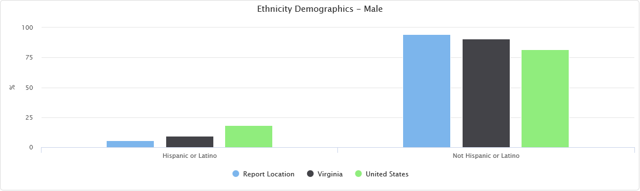

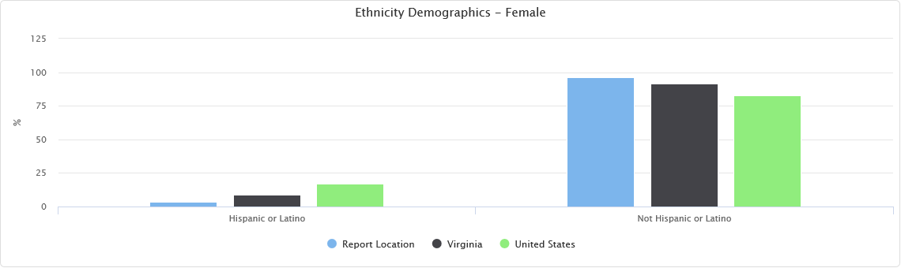

**Households in Poverty -** The number and percentage of households in poverty are shown in the report area. In 2017, it is estimated that there were 4,110 households, or 18.68%, living in poverty within the report area.

| **Report Area** | **Total Households** | **Households in Poverty** | **Percent Households in Poverty** |
| --- | --- | --- | --- |
| Report Location | 22,007 | 4,110 | 18.68% |
| Carroll County, VA | 12,517 | 2,032 | 16.2% |
| Grayson County, VA | 6,653 | 1,418 | 21.3% |
| Galax city, VA | 2,837 | 660 | 23.3% |
| Virginia | 3,105,636 | 334,000 | 10.8% |
| United States | 118,825,921 | 16,390,109 | 13.8% |

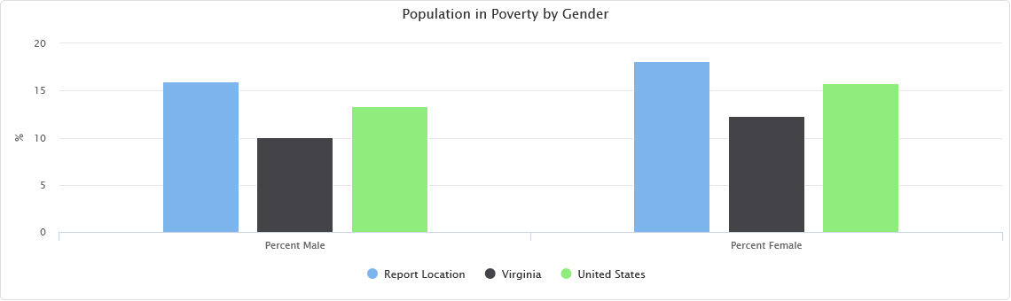

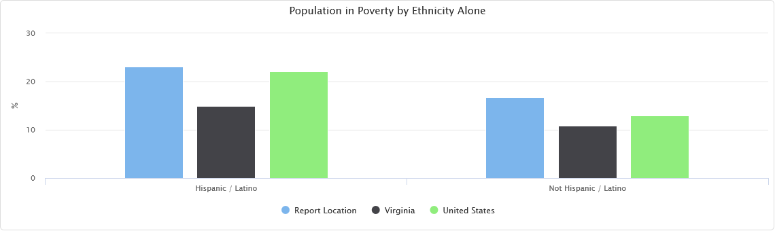

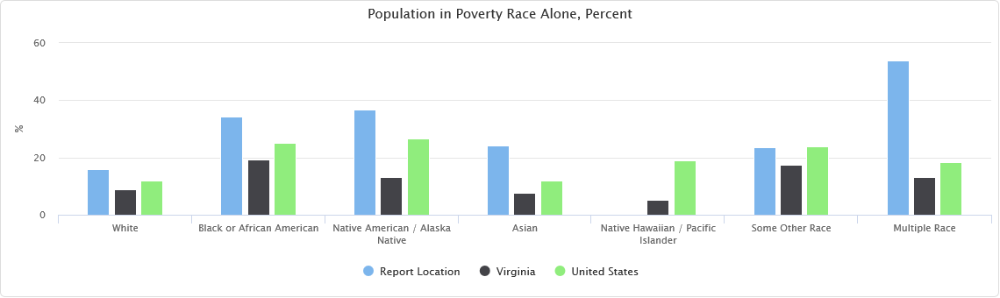

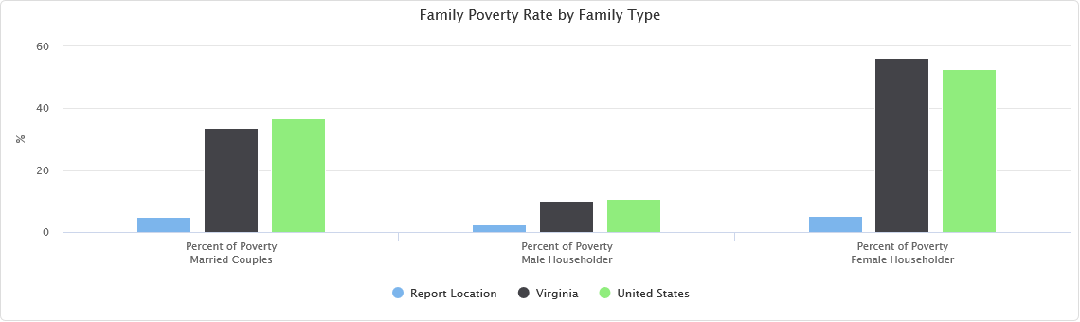

**Child Poverty Rate (ACS) Ages 0-17 -** Population and poverty estimates for children age 0-17 are shown for the report area. According to the American Community Survey 5 year data, an average of 23.9% percent of children lived in a state of poverty during the survey calendar year. The poverty rate for children living in the report area is greater than the national average of 21.2 percent.

| **Report Area** | **Ages 0-17 Total Population** | **Ages 0-17 In Poverty** | **Ages 0-17 Poverty Rate** |
| --- | --- | --- | --- |
| Report Location | 9,746 | 2,326 | 23.9% |
| Carroll County, VA | 5,662 | 955 | 16.9% |
| Grayson County, VA | 2,720 | 978 | 36% |
| Galax city, VA | 1,364 | 393 | 28.8% |
| Virginia | 1,838,741 | 273,962 | 14.9% |
| United States | 72,430,017 | 14,710,485 | 20.3% |

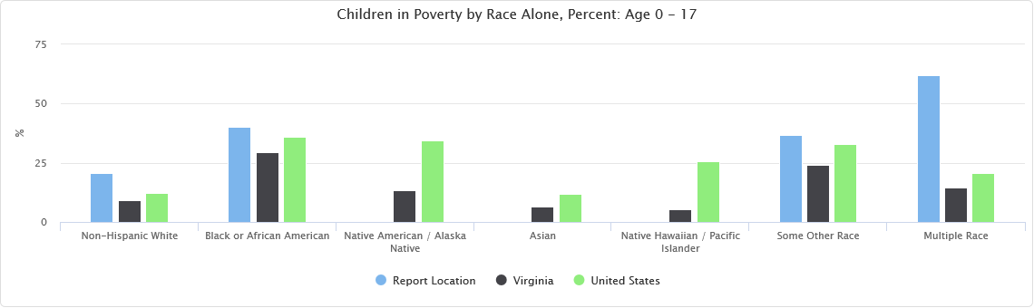

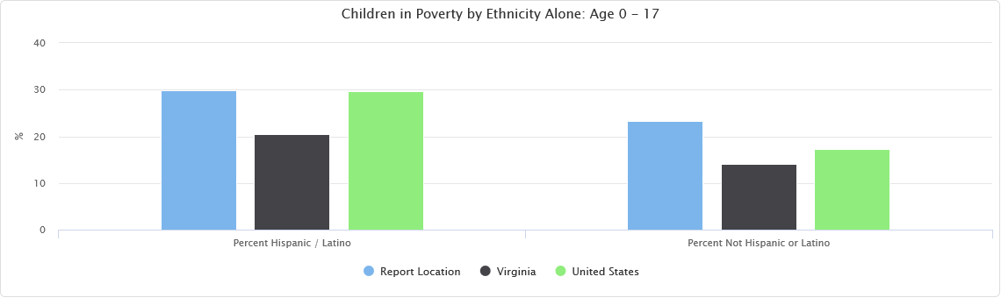

**Child Poverty Rate (ACS) Ages 0-4 -** Population and poverty estimates for children age 0-4 are shown for the report area. According to the American Community Survey 5 year data, an average of 31.9% percent of children lived in a state of poverty during the survey calendar year. The poverty rate for children living in the report area is greater than the national average of 23.6 percent. These children would be eligible to participate in Head Start and Early Head Start.

| **Report Area** | **Ages 0-4 Total Population** | **Ages 0-4 In Poverty** | **Ages 0-4 Poverty Rate** |
| --- | --- | --- | --- |
| Report Location | 2,548 | 812 | 31.9% |
| Carroll County, VA | 1,536 | 403 | 26.2% |
| Grayson County, VA | 669 | 309 | 46.2% |
| Galax city, VA | 343 | 100 | 29.2% |
| Virginia | 502,511 | 81,553 | 16.2% |
| United States | 19,532,877 | 4,390,252 | 22.5% |

**Child Poverty Rate (ACS) Ages 5-17 -** Population and poverty estimates for children age 5-17 are shown for the report area. According to the American Community Survey 5 year data, an average of 21% percent of children lived in a state of poverty during the survey calendar year. The poverty rate for children living in the report area is less than the national average of 20.3 percent.

| **Report Area** | **Ages 5-17 Total Population** | **Ages 5-17 In Poverty** | **Ages 5-17 Poverty Rate** |
| --- | --- | --- | --- |
| Report Location | 7,198 | 1,514 | 21% |
| Carroll County, VA | 4,126 | 552 | 13.4% |
| Grayson County, VA | 2,051 | 669 | 32.6% |
| Galax city, VA | 1,021 | 293 | 28.7% |
| Virginia | 1,336,230 | 192,409 | 14.4% |
| United States | 52,897,140 | 10,320,233 | 19.5% |

**Seniors in Poverty -** Poverty rates for seniors (persons age 65 and over) are shown below. According to American Community Survey estimates, there were 1,287 seniors, or 11.3% percent, living in poverty within the report area.

| **Report Area** | **Ages 65 and Up Total Population** | **Ages 65 and Up In Poverty** | **Ages 65 and Up Poverty Rate** |
| --- | --- | --- | --- |
| Report Location | 11,365 | 1,287 | 11.3% |
| Carroll County, VA | 6,553 | 732 | 11.2% |
| Grayson County, VA | 3,481 | 445 | 12.8% |
| Galax city, VA | 1,331 | 110 | 8.3% |
| Virginia | 1,161,386 | 85,838 | 7.4% |
| United States | 46,424,881 | 4,317,192 | 9.3% |

**Current Unemployment -** Labor force, employment, and unemployment data for each county in the report area is provided in the table below. Overall, the report area experienced an average 3.6% percent unemployment rate in August 2018.

| **Report Area** | **Labor Force** | **Number Employed** | **Number Unemployed** | **Unemployment Rate** |
| --- | --- | --- | --- | --- |
| Report Location | 23,025 | 22,194 | 831 | 3.6% |
| Carroll County, VA | 12,943 | 12,462 | 481 | 3.7% |
| Grayson County, VA | 7,230 | 6,994 | 236 | 3.3% |
| Galax city, VA | 2,852 | 2,738 | 114 | 4% |
| Virginia | 4,340,469 | 4,207,320 | 133,149 | 3.1% |
| United States | 162,996,774 | 156,527,318 | 6,469,456 | 4% |

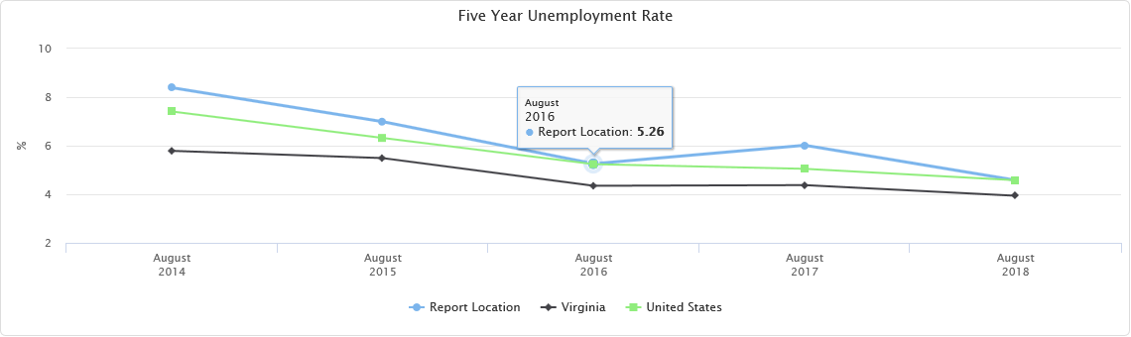

**Commuter Travel Patterns -** This table shows the method of transportation workers used to travel to work for the report area. Of the 22,106 workers in the report area, 83.7% drove to work alone while 10.4% carpooled. 0.4% of all workers reported that they used some form of public transportation, while others used some optional means including 1.6% walking or riding bicycles, and 0.3% used taxicabs to travel to work.

| **Report Area** | **Workers 16 and Up** | **Percent Drive Alone** | **Percent Carpool** | **Percent Public Transportation** | **Percent Bicycle or Walk** | **Percent Taxi or Other** | **Percent Work at Home** |
| --- | --- | --- | --- | --- | --- | --- | --- |
| Report Location | 22,106 | 83.7% | 10.4% | 0.4% | 1.6% | 0.3% | 3.5% |
| Carroll County, VA | 12,911 | 83.9% | 10.9% | 0% | 1% | 0.1% | 4.1% |
| Grayson County, VA | 6,347 | 83.1% | 9.6% | 1% | 3% | 0.7% | 2.8% |
| Galax city, VA | 2,848 | 84.8% | 10% | 0.8% | 1.2% | 0.7% | 2.4% |
| Virginia | 4,115,810 | 77.3% | 9.3% | 4.4% | 2.9% | 1.3% | 4.8% |
| United States | 148,432,042 | 76.4% | 9.2% | 5.1% | 3.3% | 1.2% | 4.7% |



**Educational Attainment -** Educational Attainment shows the distribution of educational attainment levels in the report area. Educational attainment is calculated for persons over 25, and is an estimated average for the period from 2012 to 2017.

| **Report Area** | **Percent No High School Diploma** | **Percent High School Only** | **Percent Some College** | **Percent Associates Degree** | **Percent Bachelors Degree** | **Percent Graduate or Professional Degree** |
| --- | --- | --- | --- | --- | --- | --- |
| Report Location | 19.59% | 35.93% | 20.88% | 10.16% | 9.63% | 3.81% |
| Carroll County, VA | 19.07% | 34.3% | 21.1% | 11.1% | 10.5% | 4% |
| Grayson County, VA | 18.89% | 38.9% | 19.4% | 10.1% | 9.6% | 3.2% |
| Galax city, VA | 23.48% | 36.2% | 23.5% | 6.4% | 5.7% | 4.6% |
| Virginia | 10.98% | 24.3% | 19.7% | 7.5% | 21.5% | 16.1% |
| United States | 12.69% | 27.3% | 20.8% | 8.3% | 19.1% | 11.8% |

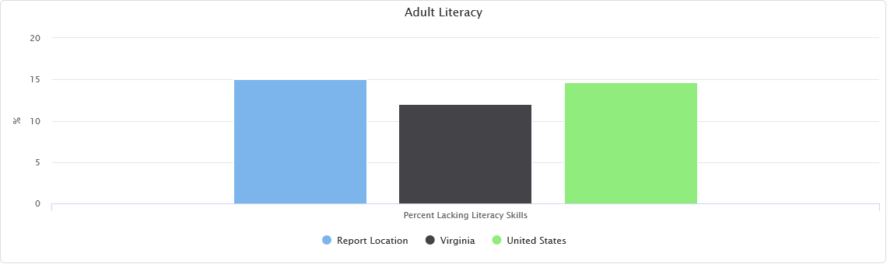

**Housing Age -** Total housing units, median year built and median age in 2017 for the report area are shown below. Housing units used in housing age include only those where the year built is known.

| **Report Area** | **Total Housing Units** | **Median Year Built** | **Median Age (from 2017)** |
| --- | --- | --- | --- |
| Report Location | 29,447 | No data | No data |
| Carroll County, VA | 16,745 | 1978 | 36 |
| Grayson County, VA | 9,218 | 1973 | 41 |
| Galax city, VA | 3,484 | 1972 | 42 |
| Virginia | 3,466,921 | 1981 | 33 |
| United States | 135,393,564 | 1977 | 37 |

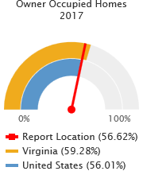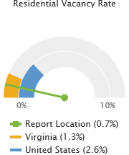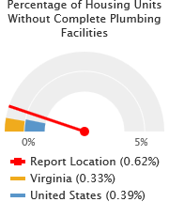

**Income Levels -** Two common measures of income are Median Household Income and Per Capita Income, based on U.S. Census Bureau estimates. Both measures are shown for the report area below. The average Per Capita income for the report area is $21,013.73, compared to a national average of $29,829.00.

| **Report Area** | **Median Household Income** | **Per Capita Income** |
| --- | --- | --- |
| Report Location | No data | $21,013.73 |
| Carroll County, VA | $37,048.00 | $21,484.00 |
| Grayson County, VA | $31,002.00 | $20,190.00 |
| Galax city, VA | $31,110.00 | $20,796.00 |
| Virginia | $66,149.00 | $34,967.00 |
| United States | $55,322.00 | $29,829.00 |

**Household Income -** Median annual household incomes in the report area for 2016 are shown in the table below. Since this reports a median amount, a "Report Area" value is not able to be calculated.

| **Report Area** | **Estimated Population** | **Median Household Income** |
| --- | --- | --- |
| Carroll County, VA | 29,733 | $40,390.00 |
| Grayson County, VA | 15,180 | $36,113.00 |
| Galax city, VA | 6,858 | $35,221.00 |
| Virginia | 8,310,301 | $68,127.00 |
| United States | 318,558,162 | $57,617.00 |

**Free and Reduced Lunch Program -** The following report shows that 4,142 students (or 59.38 percent) were eligible for free or reduced price lunches during the 2013 - 2014 school year, which is more than the national average of 52.61%.

| **Report Area** | **Total Students** | **Number Free/Reduced Price Lunch Eligible** | **Percent Free/Reduced Price Lunch Eligible** |
| --- | --- | --- | --- |
| Report Location | 6,976 | 4,142 | 59.38% |
| Carroll County, VA | 3,902 | 2,186 | 56.02% |
| Grayson County, VA | 1,684 | 1,060 | 62.95% |
| Galax city, VA | 1,390 | 896 | 64.46% |
| Virginia | 1,283,548 | 523,972 | 41.22% |
| United States | 50,611,787 | 25,893,504 | 52.61% |

**Households Receiving SNAP by Poverty Status (ACS) -** The below table shows that according to the American Community Survey (ACS), 3,014 households (or 13.7%) received SNAP payments during 2017. During this same period there were 2,374 households with income levels below the poverty level that were not receiving SNAP payments.

| **Report Area** | **Households Receiving SNAP Total** | **Households Receiving SNAP Percent** | **Households Receiving SNAP Income Below Poverty** | **Households Receiving SNAP Income Above Poverty** | **Households Not Receiving SNAP Total** | **Households Not Receiving SNAP Percent** | **Households Not Receiving SNAP Income Below Poverty** | **Households Not Receiving SNAP Income Above Poverty** |
| --- | --- | --- | --- | --- | --- | --- | --- | --- |
| Report Location | 3,014 | 13.7% | 1,736 | 1,278 | 18,993 | 86.3% | 2,374 | 16,619 |
| Carroll County, VA | 1,512 | 12.08% | 710 | 802 | 11,005 | 87.92% | 1,322 | 9,683 |
| Grayson County, VA | 938 | 14.1% | 620 | 318 | 5,715 | 85.9% | 798 | 4,917 |
| Galax city, VA | 564 | 19.88% | 406 | 158 | 2,273 | 80.12% | 254 | 2,019 |
| Virginia | 282,296 | 9.09% | 137,795 | 144,501 | 2,823,340 | 90.91% | 196,205 | 2,627,135 |
| United States | 15,029,498 | 12.65% | 7,420,946 | 7,608,552 | 103,796,423 | 87.35% | 8,969,163 | 94,827,260 |

**Federally Qualified Health Centers -** Federally Qualified Health Centers in this selected area.

| **County** | **Provider Number** | **FQHC Name** | **Address** | **City** | **Phone** |
| --- | --- | --- | --- | --- | --- |
| Carroll County | PN: 491827 | TRI-AREA HEALTH CLINIC | 14558 DANVILLE PIKE | LAUREL FORK | (703) 398-2292 |
| Grayson County | PN: 491851 | TROUTDALE MEDICAL CENTER | 67 HIGH COUNTRY LANE | TROUT DALE | (276) 677-4187 |

The following data indicates the number of children with disabilities being served in the Counties of Carroll and Grayson and the City of Galax for 2018-2019:

|  |  |  |  |  |  |  |
| --- | --- | --- | --- | --- | --- | --- |
| Agency | Developmental Delays | Speech/Language | Autism | Multiple | Other | Total Served/Notes |
| Mt. Rogers CSB |  | 38 |  |  | 14 | 143 total served, 52 ages 2-3 |
| School Districts | 35 | 37 | 3 |  | 2 | 75 |

Head Start (HS) and Early Head Start (EHS) also seeks to serve children with disabilities. The following are statistics for the number of children with disabilities served in 2017-2018:

1. EHS

12 With Speech/Language impairment, 6 Developmental Delay, 1 Unspecified, 4 Multiple Disabilities and 7 with open concerns

1. HS

20 With Speech/Language impairment, 2 Developmental Delay, 13 Multiple Disabilities and 1 open Concern.

Services were provided by LEA Or Part C Agencies- Galax City Schools, Carroll County Schools, Mt. Rogers Infant & Toddler and Grayson County Schools.

**Medicare and Medicaid Providers -** Total institutional Medicare and Medicaid providers, including hospitals, nursing facilities, Federally qualified health centers, rural health clinics and community mental health centers for the report area are shown. According to the U.S. Department of Health and Human Services, there were 18 active Medicare and Medicaid institutional service providers in the report area in the first quarter of 2018.

| **Report Area** | **Total Institutional Providers** | **Hospitals** | **Nursing Facilities** | **Federally Qualified Health Centers** | **Rural Health Clinics** | **Community Mental Health Centers** |
| --- | --- | --- | --- | --- | --- | --- |
| Report Location | 18 | 1 | 5 | 2 | 1 | 0 |
| Carroll County, VA | 5 | 0 | 2 | 1 | 0 | 0 |
| Grayson County, VA | 4 | 0 | 1 | 1 | 1 | 0 |
| Galax city, VA | 9 | 1 | 2 | 0 | 0 | 0 |
| Virginia | 1,346 | 128 | 287 | 142 | 34 | 1 |
| United States | 73,554 | 7,153 | 15,635 | 8,350 | 4,246 | 142 |

**Persons Receiving Medicare -** The total number of persons receiving Medicare is shown, broken down by number over 65 and number of disabled persons receiving Medicare for the report area. The U.S. Department of Health and Human Services reported that a total of 13,774 persons were receiving Medicare benefits in the report area in 2017. A large number of individuals in our society are aware that persons over 65 years of age receive Medicare; however, many of them are unaware that disabled persons also receive Medicare benefits. A total of 2,492 disabled persons in the report area received Medicare benefits in 2017.

| **Report Area** | **Persons Over 65 Receiving Medicare** | **Disabled Persons Receiving Medicare** | **Total Persons Receiving Medicare** |
| --- | --- | --- | --- |
| Report Location | 11,283 | 2,492 | 13,774 |
| Carroll County, VA | 5,031 | 1,072 | 6,103 |
| Grayson County, VA | 2,886 | 614 | 3,500 |
| Galax city, VA | 3,366 | 806 | 4,171 |
| Virginia | 2,445,955 | 411,404 | 2,857,360 |
| United States | 49,775,028 | 8,768,041 | 58,543,069 |

**Uninsured Population -** The uninsured population is calculated by estimating the number of persons eligible for insurance (generally those under 65) minus the estimated number of insured persons.

| **Report Area** | **Insurance Population (2017 Estimate)** | **Number Insured** | **Number Uninsured** | **Percent Uninsured** |
| --- | --- | --- | --- | --- |
| Report Location | 52,263 | 33,946 | 5,271 | 10.09% |
| Carroll County, VA | 29,767 | 19,673 | 3,009 | 10.11% |
| Grayson County, VA | 15,708 | 9,850 | 1,435 | 9.14% |
| Galax city, VA | 6,788 | 4,423 | 827 | 12.18% |
| Virginia | 8,365,952 | 6,273,038 | 692,343 | 8.28% |
| United States | 321,004,407 | 240,510,253 | 26,749,668 | 8.33% |

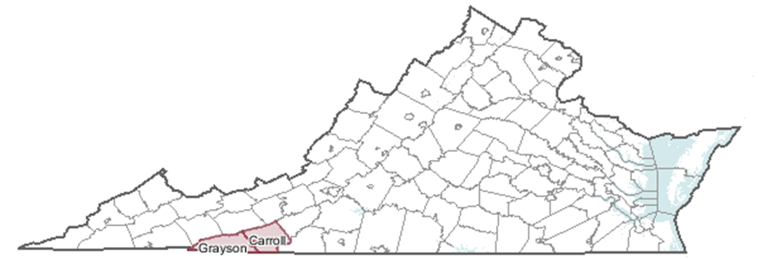

**Qualitative Data**

*Staff Surveys*

1. Appreciative Inquiry (December 2017) – The following questions were posed and the answers listed were the top three given after compilation and tabulation:
2. Community strengths (what do you like about our community/what do you enjoy):

Supportive community in which they live.

Natural beauty.

Recreational Opportunities

1. Organizations/institutions/groups/activities/resources that are assets (Who do you think is beneficial to our community?):

Active churches.

Parks and recreation.

District III

1. Opportunities/ideas/resources/partners to develop (What do you think would be valuable to the community? What other programs/services/talents can we develop?):

Youth activities for middle to high school.

More restaurants and shopping choices.

More assistance for senior citizens.

1. Top Needs in the Area (January 2019) – Staff were tasked with brainstorming needs for the area, determining if they were family, agency or community levels concerns and then ranking them to decide the top three in each category.
2. Family level: lack resources for medical/dental health, grandparent-headed households need a way to access resources available to them, teens lack activities to do in the area.
3. Agency level: more marketing is needed to promote services of the agency, funding is needed to improve facilities, better accessibility is needed to provide programs (i.e. transportation).
4. Community level: area lacks affordable housing stock, public transportation is needed in the counties, and there is a lack of living wage jobs.
5. Head Start and Early Head Start employee satisfaction surveys (2017-2018 year) – The following indicates cumulative answers on the 28% of surveys that were returned:
6. Suggestions for program improvement: need screening machines for each center to better keep up with deadlines, a third person is needed in every classroom.
7. What is working well in our program?: the Health Specialist and child staffing.
8. What trainings could be provided that would help you in your job?: refresher on Child Plus, Teaching Strategies and a nutrition class.
9. Main agency location employee satisfaction surveys (fall 2018); 35% participation:

Respondents noted that they were satisfied with their jobs and the service that the agency provides. It was noted that some would like to work closer with families in order to improve their outcomes, the main facility needs improving, communication should be improved and a lower cost insurance would be appreciated.

1. In January 2019, management staff met to discuss trends and determine the top three needs of the community. Directors from all programs were provided with notable trends in surveys, interviews and focus group data along with quantitative statistics collected by the Planner/Grant Writer. The group analyzed findings and used a trend analysis method to decide on the needs of the area.

*Customer Satisfaction Surveys*

Surveys were distributed to all program in the fall of 2018. Customers were tasked with providing their opinions on area needs, noting challenges in their own households and determining strengths in the area. They were then asked to rate their level of satisfaction with the agency’s program, services and facilities. 205 surveys were collected.

**Area Needs**

**What are the major contributors to poverty in our community? Please check the top 3.**

|  |  |  |  |
| --- | --- | --- | --- |
| **1 (139)** Alcohol/Drug Abuse | 66 Criminal History | **2 (89)** Lack of Training/Job Skills | **3 (83)**  Lack of Well-Paying Jobs w/ Benefits |
| 46 Lack of Education | 15 Language Barriers | 82 Not Enough Jobs | 35 Lack of Motivation/Encouragement to Work |

**What challenges are currently present in your household?**

|  |  |  |  |
| --- | --- | --- | --- |
| 12 Unable to secure a job. | 26 Affordable housing. | 15 Lack of Training/Job Skills | 27 Lack of GED/high school diploma. |
| 22 Lack of transportation. | 9 Safe/decent housing. | 34 No health insurance. | 8 Need resources for drug/alcohol abuse. |
| 42 Lack of child care. | 23 Home needs repairs. | 8 Low computer skills. | 14 Emergency resources (food, utility, housing, etc.) |
| 12 Lack of dental services. | 45 Cost of utilities. | 20 Divorce/co-parenting. | 3 Lack of mental health resources. |
| 27 Lack of activities for kids | 18 Health issues. | 2 Need Senior activities. | 0 Other: |

**What are the strengths found in our community? Please check the top 3.**

|  |  |  |  |
| --- | --- | --- | --- |
| 40 Low crime rate. | **1 (92)** Community events. | **2 (90)** Quality schools. | **1 (92)** Active law enforcement/emergency services. |
| 27 Tourism opportunities. | 16 Access to technology. | 18 Accessibility to larger city areas. | **3 (82)** Sense of ‘community’ and willingness to help others. |
| 0 Other: | | | |

**Ratings**

|  |  |  |  |  |  |
| --- | --- | --- | --- | --- | --- |
|  | 1 = Very Satisfied | 2 = Satisfied | 3 = Dissatisfied | 4 = Very Dissatisfied | 5 = Does Not Apply |
| **I am treated with respect by staff.** | 28 | 8 | 0 | 1 | 0 |
| **My needs are met or I am provided with resources such as referrals to other services.** | 28 | 11 | 0 | 1 | 0 |
| **The location of the building is convenient and easily accessible.** | 28 | 12 | 2 | 1 | 2 |
| **Facilities are clean and inviting.** | 28 | 11 | 0 | 1 | 2 |
| **My (or my family’s) life was improved as a results of being a customer of the agency.** | 28 | 11 | 0 | 1 | 1 |
| **I would recommend the agency to my friends and family.** | **205 Yes ____No** | | | | |

*Board Surveys*

Surveys were distributed to board members in the fall of 2018. Fifty percent of the surveys were returned providing feedback on the highest priority challenges in the area as well as the strengths of the Twin Counties.

Highest to lowest priority ranking of challenges:

1. Alcohol/drug abuse
2. No enough jobs
3. Health issues
4. Lack of well-paying jobs with benefits
5. Safe/decent housing

Area Strengths:

1. Active law enforcement/emergency services
2. Community events
3. Sense of ‘community’ and willingness to help others

*Key Informant Interviews*

Interviews were conducted with directors of the three local Department of Social Services. This occurred in the fall of 2018. The following results were collected:

1. What do you feel are the top three needs that families are facing in our community that prevents them from self-sufficiency?

Substance abuse (3)

Lack of transportation (1)

Insufficient access to mental health care (1)

Access to child care (2)

Living-wage income (1)

1. What should we as a community do to alleviate those needs?

More cost-effective drug treatment resources (3)

Public transportation system (1)

Increased workforce development for more training/education (1)

Additional child care facilities are needed (1)

1. As a stakeholder do you have any suggestions on how our community at-large may become involved in creating change for the previously stated needs?

“More access to drug treatment, which could trickle down to help with transportation issues and external supports. Many of the families we work with have lost their license, job, etc. because of drug use and/or criminal charges; if we were able to combat the drug issues the other needs could be alleviated.”

“Creating programs within our community that may assist in helping with (the mentioned issues). Creating a needle exchange program that would also help people access proper drug rehabilitation services if they are wanting help getting clean. Trying to bring new mental health agencies in the area that would have the ability to offer crisis services and ongoing services. Seeking churches that are willing to become a private daycare provider that could also provide care on a sliding fee scale.”

“Increase education in the high schools about the need for skilled laborers, programs offered through WCC for free education and training.”

*Community Surveys*

Surveys were posted to the agency’s Facebook page and website. Ninety-one respondents participated.

|  |  |  |  |  |
| --- | --- | --- | --- | --- |
| Question01 | Please indicate in which area that you live. (Mandatory) | | | |
|  | Count | Percent |  |
| [Carroll County](https://app.crowdsignal.com/surveys/2403767/report) | 47 | 52% |  |
| [Grayson County](https://app.crowdsignal.com/surveys/2403767/report) | 26 | 29% |  |
| [Galax City](https://app.crowdsignal.com/surveys/2403767/report) | 17 | 19% |  |
| [Other Option](https://app.crowdsignal.com/surveys/2403767/report) | 1 | 1% |  |

|  |  |  |  |  |
| --- | --- | --- | --- | --- |
| Question02 | Please indicate your age range. (Mandatory) | | | |
|  | Count | Percent |  |
| [35-49](https://app.crowdsignal.com/surveys/2403767/report) | 35 | 38% |  |
| [50+](https://app.crowdsignal.com/surveys/2403767/report) | 34 | 37% |  |
| [18-34](https://app.crowdsignal.com/surveys/2403767/report) | 22 | 24% |  |

|  |  |  |  |  |
| --- | --- | --- | --- | --- |
| Question03 | Please indicate what segment of the community you are representing. (Mandatory) | | | |
|  | Count | Percent |  |
| [Community Resident](https://app.crowdsignal.com/surveys/2403767/report) | 82 | 90% |  |
| [Community Organization](https://app.crowdsignal.com/surveys/2403767/report) | 8 | 9% |  |
| [Business Owner](https://app.crowdsignal.com/surveys/2403767/report) | 1 | 1% |  |
| [Elected Official](https://app.crowdsignal.com/surveys/2403767/report) | 0 | 0% |  |

|  |  |  |  |  |
| --- | --- | --- | --- | --- |
| Question04 | In your opinion, what are the major contributors to poverty? Please check the top 3. (Mandatory) | | | |
|  | Count | Percent |  |
| [Lack of well-paying jobs with benefits.](https://app.crowdsignal.com/surveys/2403767/report) | 60 | 22% |  |
| [Alcohol/Drug Abuse](https://app.crowdsignal.com/surveys/2403767/report) | 50 | 18% |  |
| [Low motivation/encouragement to work.](https://app.crowdsignal.com/surveys/2403767/report) | 45 | 16% |  |
| [Not enough jobs.](https://app.crowdsignal.com/surveys/2403767/report) | 29 | 11% |  |
| [Lack of training/job skills for available jobs.](https://app.crowdsignal.com/surveys/2403767/report) | 25 | 9% |  |
| [Lack of education.](https://app.crowdsignal.com/surveys/2403767/report) | 24 | 9% |  |
| [Substandard/unaffordable housing in the area.](https://app.crowdsignal.com/surveys/2403767/report) | 19 | 7% |  |
| [Criminal History](https://app.crowdsignal.com/surveys/2403767/report) | 14 | 5% |  |
| [Language barriers.](https://app.crowdsignal.com/surveys/2403767/report) | 4 | 1% |  |
| [Other Option](https://app.crowdsignal.com/surveys/2403767/report) | 3 | 1% |  |

|  |  |  |  |  |  |  |
| --- | --- | --- | --- | --- | --- | --- |
| Question05 | If you think EMPLOYMENT is an issue in our area, please check the top 3 reasons. (Mandatory) | | | | |  |
|  | | Count | Percent |  |
| [Lack of good-paying jobs with benefits.](https://app.crowdsignal.com/surveys/2403767/report) | | 60 | 23% |  |
| [Not enough jobs/employers coming to the area.](https://app.crowdsignal.com/surveys/2403767/report) | | 46 | 18% |  |
| [Lack of skills/education for available jobs.](https://app.crowdsignal.com/surveys/2403767/report) | | 30 | 12% |  |
| [Lack of job soft skills (attendance, punctuality, peer interaction, applying for jobs, interviewing, etc.)](https://app.crowdsignal.com/surveys/2403767/report) | | 29 | 11% |  |
| [Employers/jobs leaving the area.](https://app.crowdsignal.com/surveys/2403767/report) | | 25 | 10% |  |
| [Not enough jobs.](https://app.crowdsignal.com/surveys/2403767/report) | | 24 | 9% |  |
| [Lack of child care.](https://app.crowdsignal.com/surveys/2403767/report) | | 19 | 7% |  |
| [Lack of transportation.](https://app.crowdsignal.com/surveys/2403767/report) | | 15 | 6% |  |
| [Other Option](https://app.crowdsignal.com/surveys/2403767/report) | | 5 | 2% |  |
| [I don't think EMPLOYMENT is an issue in my community.](https://app.crowdsignal.com/surveys/2403767/report) | | 4 | 2% |  |

|  |  |  |
| --- | --- | --- |
| Question06 | If you think HOUSING is an issue in our community, please check the top 3 reasons. (Mandatory) |  |

|  | Count | Percent |  |
| --- | --- | --- | --- |
| [Unaffordable housing.](https://app.crowdsignal.com/surveys/2403767/report) | 49 | 21% |  |
| [Credit issues hindering purchasing/renting.](https://app.crowdsignal.com/surveys/2403767/report) | 42 | 18% |  |
| [Cost of utilities.](https://app.crowdsignal.com/surveys/2403767/report) | 28 | 12% |  |
| [Low number of houses/units available to rent.](https://app.crowdsignal.com/surveys/2403767/report) | 27 | 12% |  |
| [Unsafe/substandard housing.](https://app.crowdsignal.com/surveys/2403767/report) | 23 | 10% |  |
| [I don't think HOUSING is an issue in my community.](https://app.crowdsignal.com/surveys/2403767/report) | 17 | 7% |  |
| [Lack of knowledge on how to purchase a home.](https://app.crowdsignal.com/surveys/2403767/report) | 14 | 6% |  |
| [Emergency housing needs (home repair, disability accessible, heating costs, etc.)](https://app.crowdsignal.com/surveys/2403767/report) | 12 | 5% |  |
| [Lack of emergency housing/shelters.](https://app.crowdsignal.com/surveys/2403767/report) | 11 | 5% |  |
| [Lack of knowledge of tenant/landlord rights.](https://app.crowdsignal.com/surveys/2403767/report) | 8 | 3% |  |
| [Other Option](https://app.crowdsignal.com/surveys/2403767/report) | 2 | 1% |  |
| [Lack of indoor plumbing.](https://app.crowdsignal.com/surveys/2403767/report) | 0 | 0% |  |

|  |  |  |
| --- | --- | --- |
| Question07 | If you think EDUCATION is an issue in our community, please check the top 3 reasons. (Mandatory) |  |

|  | Count | Percent |  |
| --- | --- | --- | --- |
| [Limited access to positive youth programming promoting further education/career development.](https://app.crowdsignal.com/surveys/2403767/report) | 39 | 18% |  |
| [Lack of GED/High School diploma.](https://app.crowdsignal.com/surveys/2403767/report) | 33 | 15% |  |
| [Low computer skills.](https://app.crowdsignal.com/surveys/2403767/report) | 28 | 13% |  |
| [Lack of access to technology (computers, internet, etc.)](https://app.crowdsignal.com/surveys/2403767/report) | 27 | 12% |  |
| [Lack of/cost of child care.](https://app.crowdsignal.com/surveys/2403767/report) | 27 | 12% |  |
| [I don't think EDUCATION is an issue in my community.](https://app.crowdsignal.com/surveys/2403767/report) | 22 | 10% |  |
| [Lack of transportation.](https://app.crowdsignal.com/surveys/2403767/report) | 15 | 7% |  |
| [Lack of early reading skills.](https://app.crowdsignal.com/surveys/2403767/report) | 11 | 5% |  |
| [Lack of preschool opportunities.](https://app.crowdsignal.com/surveys/2403767/report) | 8 | 4% |  |
| [Language barriers.](https://app.crowdsignal.com/surveys/2403767/report) | 5 | 2% |  |
| [Other Option](https://app.crowdsignal.com/surveys/2403767/report) | 4 | 2% |  |

|  |  |  |
| --- | --- | --- |
| Question08 | If you think HEALTH/NUTRITION is an issue in our community, please check the top 3 reasons. (Mandatory) |  |

|  | Count | Percent |  |
| --- | --- | --- | --- |
| [Lack of health insurance.](https://app.crowdsignal.com/surveys/2403767/report) | 37 | 15% |  |
| [Lack of dental services for lower income households.](https://app.crowdsignal.com/surveys/2403767/report) | 35 | 15% |  |
| [Access to affordable healthy food choices.](https://app.crowdsignal.com/surveys/2403767/report) | 31 | 13% |  |
| [Obesity problems.](https://app.crowdsignal.com/surveys/2403767/report) | 26 | 11% |  |
| [Not knowing what resources are available.](https://app.crowdsignal.com/surveys/2403767/report) | 23 | 10% |  |
| [Low food stamp amounts.](https://app.crowdsignal.com/surveys/2403767/report) | 15 | 6% |  |
| [Low number of Medicaid/Medicare providers in the area.](https://app.crowdsignal.com/surveys/2403767/report) | 14 | 6% |  |
| [Resources for drug use and rehabilitation.](https://app.crowdsignal.com/surveys/2403767/report) | 14 | 6% |  |
| [Lack of education on proper nutrition.](https://app.crowdsignal.com/surveys/2403767/report) | 11 | 5% |  |
| [I don't think HEALTH/NUTRITION is an issue in my community.](https://app.crowdsignal.com/surveys/2403767/report) | 11 | 5% |  |
| [Food resources not available (Senior meals, Meals on Wheels, food pantries, etc.).](https://app.crowdsignal.com/surveys/2403767/report) | 8 | 3% |  |
| [Lack of mental health education and service providers.](https://app.crowdsignal.com/surveys/2403767/report) | 8 | 3% |  |
| [Other Option](https://app.crowdsignal.com/surveys/2403767/report) | 6 | 3% |  |

|  |  |  |
| --- | --- | --- |
| Question09 | If you think OTHER HOUSEHOLD NEEDS are an issue in our community, please check the top 3 reasons. (Mandatory) |  |

|  | Count | Percent |  |
| --- | --- | --- | --- |
| [Lack of positive programs/activities for youth.](https://app.crowdsignal.com/surveys/2403767/report) | 55 | 25% |  |
| [Alcohol/drug abuse.](https://app.crowdsignal.com/surveys/2403767/report) | 50 | 22% |  |
| [Domestic issues (violence, child abuse, elderly abuse, etc.).](https://app.crowdsignal.com/surveys/2403767/report) | 39 | 17% |  |
| [Lack of private and public transportation.](https://app.crowdsignal.com/surveys/2403767/report) | 30 | 13% |  |
| [Emergency resources (food, shelter, utilities, fuel, medical, etc.).](https://app.crowdsignal.com/surveys/2403767/report) | 26 | 12% |  |
| [Lack of legal assistance.](https://app.crowdsignal.com/surveys/2403767/report) | 8 | 4% |  |
| [I don't thinks OTHER HOUSEHOLD NEEDS are issues in my community.](https://app.crowdsignal.com/surveys/2403767/report) | 8 | 4% |  |
| [Lack of clothing.](https://app.crowdsignal.com/surveys/2403767/report) | 6 | 3% |  |
| [Other Option](https://app.crowdsignal.com/surveys/2403767/report) | 2 | 1% |  |

|  |  |  |
| --- | --- | --- |
| Question10 | Please identify the top 3 strengths that our area has to offer you and your family. (Mandatory) |  |

|  | Count | Percent |  |
| --- | --- | --- | --- |
| [Sense of 'community' and willingness to help others.](https://app.crowdsignal.com/surveys/2403767/report) | 50 | 20% |  |
| [Community events (parades, festivals, etc.).](https://app.crowdsignal.com/surveys/2403767/report) | 45 | 18% |  |
| [Active law enforcement and emergency medical services.](https://app.crowdsignal.com/surveys/2403767/report) | 42 | 17% |  |
| [Tourism opportunties (New River Trail, Rex Theater, access to recreational activities, etc.).](https://app.crowdsignal.com/surveys/2403767/report) | 36 | 14% |  |
| [Quality schools.](https://app.crowdsignal.com/surveys/2403767/report) | 32 | 13% |  |
| [Low crime rate.](https://app.crowdsignal.com/surveys/2403767/report) | 28 | 11% |  |
| [Accessibility to larger cities.](https://app.crowdsignal.com/surveys/2403767/report) | 10 | 4% |  |
| [Other Option](https://app.crowdsignal.com/surveys/2403767/report) | 5 | 2% |  |
| [Access to technology.](https://app.crowdsignal.com/surveys/2403767/report) | 4 | 2% |  |